Program of Study (POS) System
Requirements Specification

Copyright © 1995 – 2003 Atlantic Systems Guild
This document may be used, modified or copied for internal use, provided this copyright is acknowledged. This is intended to form the basis of your requirements specification. It may not be sold, or used for commercial gain or other purposes without prior written permission.

Updates to this template are posted on our web sites www.systemsguild.com and www.volere.co.uk

Requirements Specification

Table of Contents
PROJECT DRIVERS
1. The Purpose of the Product
2. Client, Customer and other Stakeholders
3. Users of the Product
PROJECT CONSTRAINTS
4. Mandated Constraints
5. Naming Conventions and Definitions
6. Relevant Facts and Assumptions
FUNCTIONAL REQUIREMENTS
7. The Scope of the Work
8. The Scope of the Product
9. Functional and Data Requirements
NON-FUNCTIONAL REQUIREMENTS
10. Look and Feel Requirements
11. Usability Requirements
12. Performance Requirements
13. Operational Requirements
14. Maintainability and Portability Requirements
15. Security Requirements
16. Cultural and Political Requirements
17. Legal Requirements
PROJECT ISSUES
18. Open Issues
19. Off-the-Shelf Solutions
20. New Problems
21. Tasks
22. Cutover
23. Risks
24. Costs
25. User Documentation and Training
26. Waiting Room
27. Ideas for Solutions

1 The Purpose of the Product

1a. The user problem or background to the project effort.

The purpose of the product is to create an automated online system to provide assistance to students, faculty and administrative staff, in determining the course work for the student leading to successful graduation.

The current system is cumbersome and mostly manual. Due to the human factors involved, it is error prone and inefficient. The team has observed that the students have to be physically involved in each and every activity like registration and petition for graduation. Additionally, the amount of paperwork involved in the whole process is redundant and resource-intensive. Therefore, we can safely conclude that the current system can be replaced by the system that we plan to develop.

1b. Goals of the project.

The advisor may use the system to create, approve and review the Program of Study (POS) on-line.

Each student may view his/her POS.

As the POS is displayed, grades and dates are imported from PAWS/Banner and inserted into the POS.

All authorized users may run a graduation check for a particular student to determine the deficiencies that must be corrected before that student can graduate.

A department may run a graduation check for all students who have petitioned for graduation.

The registrar may run a graduation check for all students who have petitioned for graduation.

Each student will be able to get his/her POS approved more easily. This will be measured by sending a questionnaire to users to rate their experience.

A department may run a check to determine outstanding course needs of current students.

This product will reduce time spent by advisors in the advisement process by TBD%. This will be measured by sending a questionnaire to users to rate their experience.

This product will increase student satisfaction of course offering selections by TBD%. This will be measured by sending a questionnaire to users to rate their experience.

2 Client, Customer and other Stakeholders

2a. The client is the person/s paying for the development, and owner of the delivered system.

The client for the first deliverable of the system is Dr. Bond, who represents Florida Tech. The company retains the right to market future versions of the product to other clients.

2b. The customer is the person/s who will buy the product from the client.

The customer is the FIT VP of Student Affairs. Other possible customers are the VP of Student Affairs at other universities, corporate training coordinators, and High School Guidance coordinators.

2c. Other stakeholders

Other stakeholders include:

Users (detailed in section 3)

System Developers

Banner System Developers

Testers

Parents of Students – Want students to stay on track for on-time graduation

Employers of Students – When paying tuition, employer wants student to stay on track for on-time graduation

Legal Experts – Need knowledge of privacy laws.

Domain Experts – Need knowledge of university policies, generic degree program requirements

Usability Experts – Need knowledge of web usability.

Security Experts – Need knowledge of web and system security.

Marketing Department – Wants to market the product to other customers.

3 Users of the Product

Student – (Undergraduate, Graduate) – Wants to be able to easily update POS and submit for advisor approval. (Key user)

Advisor – Wants easy notification and approval of student POS. (Key user)

Department Chair / Admin – (Key user)

Wants to be able to enter major requirements, update course offerings, review POS of all students in major, review outstanding courses needed by students to use for planning course offerings, run graduation check.

Some departments may be reluctant to use on-line system. Interface must be easy to learn.

Registrar – Want to be able to create and update university policy. (Secondary user)

Hacker – Wants to interrupt system availability or corrupt system data.

System Admin – Wants to perform system upgrades, perform backups and archiving, add new students. They may want a similar interface as Banner system if the same person will be using both systems.

User Participation

Student – Get inputs for interface prototyping and usability.

Advisor – Get inputs for interface prototyping and usability.

Department Chair / Admin – Get inputs for interface prototyping and usability.

Registrar – Get inputs on university policies.

Hacker (or representative) – Get inputs on system and network vulnerabilities.

System Admin – Get inputs on upgrade, backup, cutover processes.

4 Mandated Constraints

4a. Solution constraints

The product must be accessible on-line.

The product must be compatible with multiple web browsers.

The product must have a user interface that is web compatible.

The product must be configurable to update university policies and degree requirements.

The system cannot be brought down for maintenance purposes for more than 6 hours a month or 1 day for a semester.

The system must be able to interface with multiple university record database formats. (For the first system, Banner is the format supported. Want flexible design to support other databases for future systems.)

4b. Implementation environment of the current system

The current system is a manual process that contains no formal software implementation.

4c. Partner applications
Content

The product must be compatible with PAWS/Banner systems.

Banner Database Version 6.0

PAWS Release 5.5

4d. Off-the-shelf software

No COTS are mandated by the system.

4e. Anticipated workplace environment

Users may not have audio capability on their system, so audible signals must be accompanied by visual ones.

The system must handle lost network connections.

The system must utilize web browser compatible user interface.

4f. How long do the developers have to build the system?

The product must be ready to use by the Fall 2016. (TBD – Add consequence if this is missed.)

4g. What is the financial budget for the system?

TBD

5 Naming Conventions and Definitions

Academic Credit: Official certification or recognition that a student has successfully completed a course of study.

Credit Hour: A college credit earned for the corresponding time, in hours, spent in-class lecture/meeting

Course Reference Number (CRN): The unique identification number by which a course can be distinguished or referred to.

Course Title: A short descriptive name given to the course that may be offered by the university.

Audit: A student may audit a course with the permission of his or her advisor and payment of an audit fee. An auditor does not receive a grade; an AU is recorded on the transcript in place of the grade if the auditor has, in general, maintained a satisfactory course attendance (usually 75 percent class attendance) and completed the appropriate assignments. If the student does not meet requirements, a final grade of F may be awarded. No changes in registration from credit to audit or from audit to credit will be permitted after the first week of classes.

Major: This relates to the field of academic study in which a student specializes.

Student Status - Personal information in the student profile. This includes course history and progress towards earning a designation, tests scores from previous exams. It allows students to enroll for any type of exam electronically and receive important updates and information directly.

Advisor - Each student is assigned a faculty adviser in his or her major academic unit. The adviser monitors the student’s academic progress toward a degree.

Program of Study (POS) - A plan that indicates required courses for a selected major and ensure that courses are scheduled in proper succession.

Program Plan – A student’s POS that includes selected degree program options and electives.

Part-time Student - An undergraduate student is considered one-half time for six to 11 credits; less than one-half time for one to five credits. A graduate student is considered half time with five to eight credits and less than half time with one to four credits.

Full-time Student - An undergraduate student is considered full time if he or she is enrolled for 12 or more credits. A graduate student is considered full time when enrolled for nine or more credits.

Account Hold - The suspension of an account due to a discrepancy.

Expected Graduation Date -The estimated date the student plans to graduate based on his/her program plan.

Transfer Credit – A course (or courses) taken at another institution of higher education that is to be substituted for a course (or courses) taken at the current university.

Time Limit - The date at which a program of study is no longer valid.

Petition to Graduate - A form that is filled out and filed with the registrar when a student has completed his/her program plan and is planning to receive a degree.

Petition to Graduate Deadline – The deadline by which a student must submit a petition to graduate for a particular term.

Incomplete Status – A status assigned to a course when a student fails to complete the necessary work to receive a grade. The status is accompanied by a deadline by which the work must be completed and a grade assigned.

User Type - Users of the system can belong to one to five (TBD) roles to determine the operations they are authorized to perform:

POS view (students/advisors),

POS approve (advisors/dept. chair)

POS query (dept admin/registrar),

POS admin (dept admin/registrar),

System Admin.

A user can have many roles. Roles can have many users.

Student – Any full or part-time student. Each student has a POS.

Approver – Any person who is authorized to approve a POS. This may include advisors, department heads, and student coordinators.

POS Admin – Any person who is authorized to update a POS template. This may include registrar, department heads, and student coordinators.

6 Relevant Facts and Assumptions

6a. External factors that have an effect on the product, but are not mandated requirements constraints.

TBD – Add business rules on university policy, courses, graduation criteria, etc. Relevant facts might contribute to requirements. They will have an effect on the eventual design of the product.

CS Dept maintains a separate database with comprehensive exam scores, copy is sent to registrar. (Bond)

CS Dept maintains record of Thesis pass/fail. (Bond)

Current documents/forms that are used:
Official Forms
- Registration Form
- Request to Study at Another Institution
- Petition for equivalency examination
- Change/Update Information
- Change in Registration/Status
- Masters Degree Program Plan
- Request for Change in Graduate Program Plan
Program Plans
- B. S. Communication 7183 flowchart
- B. S. Computer Science flowchart (03-04)
- General Studies flowchart
Other
- Sample Petition To Graduate stapled packet

6b. Assumptions that the team are making about the project

TBD.

7 The Scope of the Work

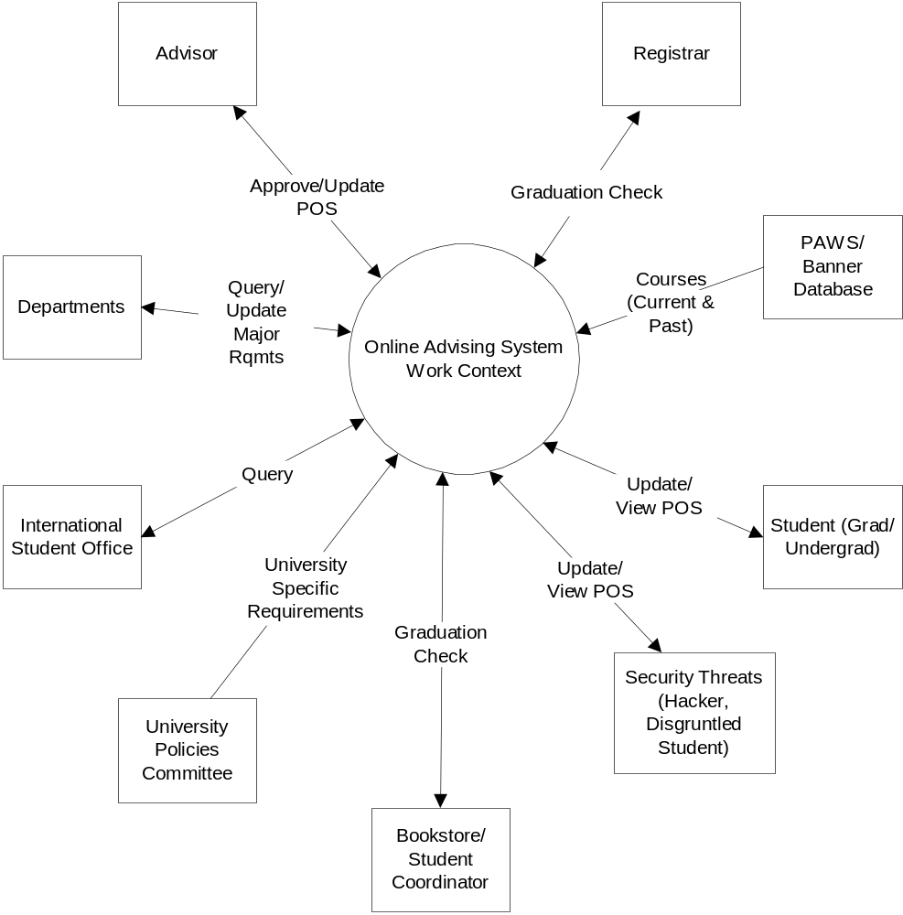

Event List

Business Event | Inputs & Outputs
- User creates POS template | Template (in)  Academic year (in)  Major (in)  Track/Focus (in)  Required Courses (in)  List allowable electives (in)  POS template (out)
- User updates POS template | Template (in)  Academic year (in)  Major (in)  Track/Focus (in)  Required Courses (in)  List allowable electives (in)  POS template updated (out)
- User deletes POS template. | Academic year (in)  POS template deleted (out)
- User queries for outstanding course needs. | Department number (in)  Counts for courses needed sorted by course (out)
- User creates a Program of Study (POS) | Student Records (in)  Advisor Information (in)  Course Information (in)  Sample POS (out)
- Student edits POS. | POS (out)  Updated POS (in)
- Advisor modifies a POS. | Student Records (in)  Advisor Information (in)  Updated POS (out)  Authorization Email (out)
- Approver reviews a POS. | Student Records (in)  Advisor Information (in)
- Student views POS. | POS (out)
- Student submits POS for approval. | Approval request (in)  Confirmation (out)
- Approver approves a POS. | Student Records (in)  Advisor Information (in)  Updated POS (out)  Confirmation Email (out)
- Student petitions to graduate. | Petition request (in)  Confirmation (out)
- User queries system for students who have petitioned to graduate. | Semester (in)  College (in)  Degree Type (in)  Student Type (in)  List of students (out)  See use case for sort options.
- Clear out Graduated Students
- Update student records with courses and grades. | Course number (in)  Course grade (in)  Student ID (in)  POS updated (out)
- Protect student records
- Change adjacent system or underlying computing technology

8 The Scope of the Product

The current system is centralized with the registrar doing most of the work of the POS query and POS admin roles. Our system will allow for decentralization of those roles to any authorized user. Our system will also allow for a centralized system in that only a few users can be given the “modify/query” roles in the system.

Business Event | Inputs & Outputs | Use Case
- User creates POS template | Template (in)  Academic year (in)  Major (in)  Track/Focus (in)  Required Courses (in)  List allowable electives (in)  POS template (out) | User creates POS template.
- User updates POS template | Template (in)  Academic year (in)  Major (in)  Track/Focus (in)  Required Courses (in)  List allowable electives (in)  POS template updated (out) | User updates POS template
- User deletes POS template. | Academic year (in)  POS template deleted (out) | User deletes POS template
- User queries for outstanding course needs. | Department number (in)  Counts for courses needed sorted by course (out) | User queries for outstanding course needs.
- User creates a Program of Study (POS) | Student Records (in)  Advisor Information (in)  Course Information (in)  Sample POS (out) | Update POS – (A) Create a new student’s POS.
- Student edits POS. | POS (out)  Updated POS (in) | Update POS – (B) Student POS is updated.
- Advisor modifies a POS. | Student Records (in)  Advisor Information (in)  Updated POS (out)  Authorization Email (out) | Update POS – (B) Student POS is updated.
- Approver reviews a POS. | Student Records (in)  Advisor Information (in) | Update POS – (C) Student POS is viewed.
- Student views POS. | POS (out) | Update POS – (C) Student POS is viewed.
- Student submits POS for approval. | Approval request (in)  Confirmation (out) | Student submits POS for approval.
- Approver approves a POS. | Student Records (in)  Advisor Information (in)  Updated POS (out)  Confirmation Email (out) | Approver approves a POS.
- Student petitions to graduate. | Petition request (in)  Confirmation (out) | Student petitions to graduate.
- User queries system for students who have petitioned to graduate. | Semester (in)  College (in)  Degree Type (in)  Student Type (in)  List of students (out)  See use case for sort options. | User queries system for students who have petitioned to graduate.
- Clear out Graduated Students |  | Clear out Graduated Students
- Update student records with courses and grades. | Course number (in)  Course grade (in)  Student ID (in)  POS updated (out) | Update POS records with data.
- Protect student records |  | Protect student records
- Change adjacent system or underlying computing technology | New database  New browser  New operating system | Change adjacent system or underlying computing technology

Use Cases

User/actor name

POS Admin
Description
POS Admin creates POS template.
Fit Criterion

A POS Admin shall be able to create a POS template.
Use Case Scenarios

Prerequisite: User created and has POS admin role added.
Trigger: Timer expires and system sends electronic communication to “POS query” users that new templates might need to be created. A new major is created.
Note: Inputs need to allow for ranges of courses and Boolean type logic to create sets of courses.
- User logs in and has “POS admin” role access (password) (input).
- User selects to create POS template (input).
- System allows user to select an existing template or a default template (output).
- User selects template (input).
- User enters academic year (input).
- User enters major (input).
- User enters track/focus (optional input).
- User enters required courses (input).
- User enters elective courses (input).
- User saves POS template (input).
- System creates POS template (output).

User/actor name

POS Admin
Description
POS Admin updates POS template.
Fit Criterion

A POS Admin shall be able to update a POS template.
Use Case Scenarios

Prerequisite: User created and has POS admin role added. An existing POS template has been created.
Trigger: “POS Admin” needs to make a change to an existing POS template.
Note: Inputs need to allow for ranges of courses and Boolean type logic to create sets of courses.
- User logs in and has “POS admin” role access (password) (input).
- User selects to update POS template (input).
- System returns list of created POS template (output).
- User selects template (input).
- User enters academic year (input).
- User enters major (input).
- User enters track/focus (optional input).
- User modifies required courses (input).
- User modifies elective courses (input).
- User saves POS template (input).
- System updates POS template (output).

User/actor name

POS Admin
Description
POS Admin deletes POS template.
Fit Criterion

A POS Admin shall be able to delete a POS template.
Use Case Scenarios
Prerequisite: User created and has POS admin role added. An existing POS template has been created.
Trigger: “POS Admin” needs to delete an existing POS template.
- User logs in and has “POS admin” role access (password) (input).
- User selects to delete POS template (input).
- System returns list of created POS template (output).
- User selects template (input).
- System confirms delete request (output).
- User confirms delete (input).
- System deletes POS template (output).

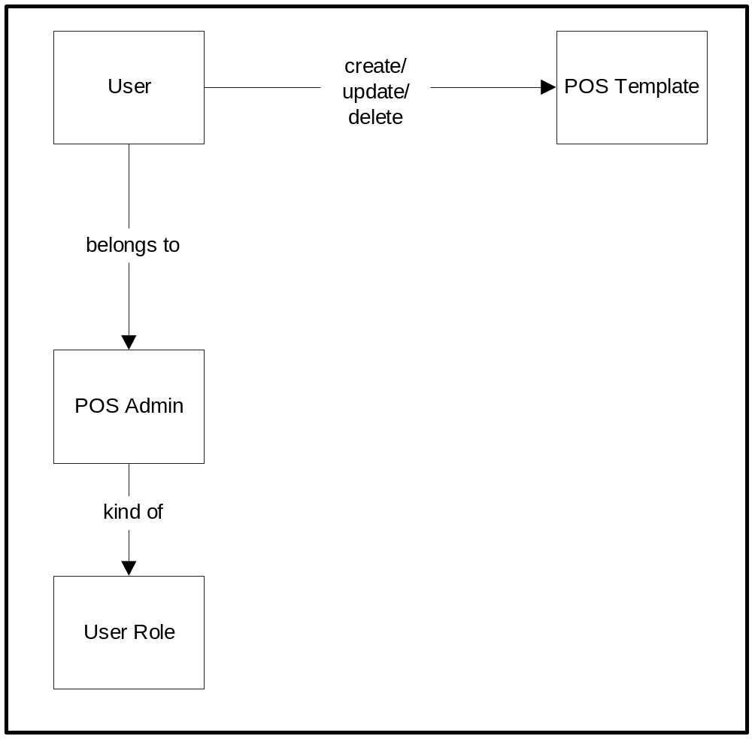 Create/Update/Delete POS Template Diagram

User/actor name

POS Query User
Description
User queries system for outstanding course needs.
Fit Criterion

The system shall return a list of courses needed and number of students for each course.
Use Case Scenarios
Prerequisite: User created and has POS query role added.
Trigger: Timer expires and system sends electronic communication to “POS query” users that next semester course selections might need to be reviewed.
- User logs in and has “POS query” role access (password) (input).
- User selects to query for outstanding class list (input).
- User selects college (optional input).
- User selects department (optional input).
- User selects student type (graduate/undergraduate) (optional input).
- System returns list of courses and number of students for each course (output).

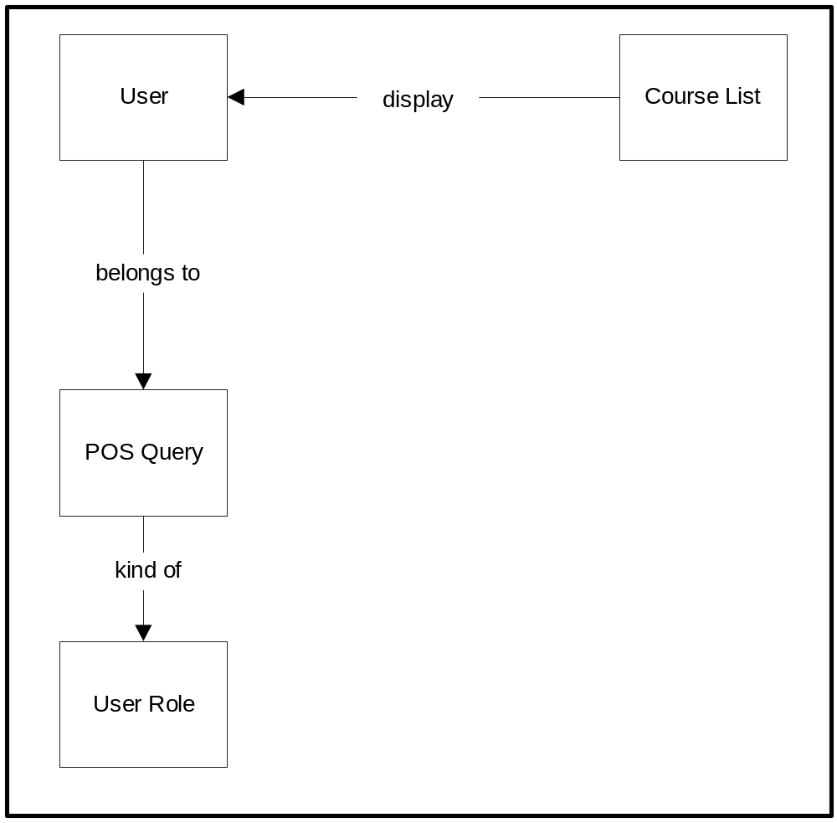 Query for Course Offerings

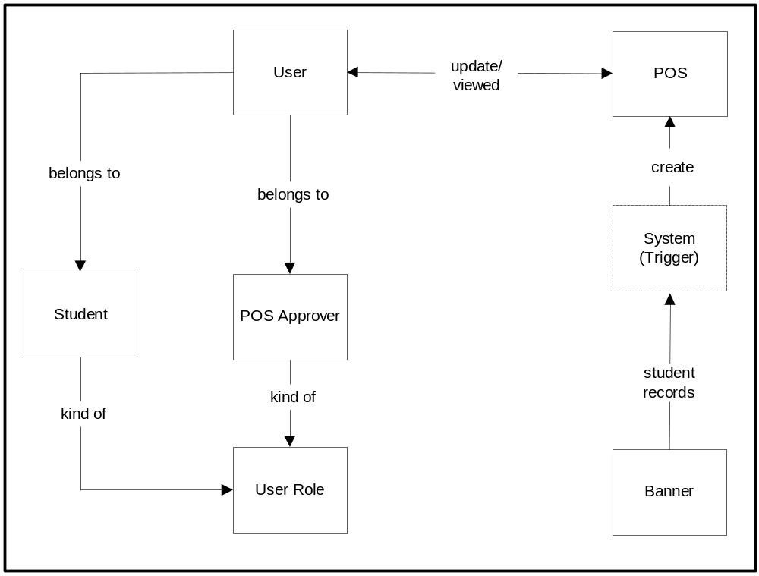 POS Management
User/actor name

POS Approver, POS Student
Description
User views/edits POS.
Fit Criterion

The user shall be able to view and edit the POS. Specific fields may be able to be changed based on user’s role.
Use Case Scenarios
Update POS – (A) System creates a new student POS.
Trigger: Timer.
- System retrieves student records from Banner and detects any new students that have been added.
- System retrieves student information (Name, SSN, major code) for each new student.
- For each new student, system creates default POS.

Update POS – (B) Student POS is updated.
Trigger: “Student” or “POS approver” needs to update an existing POS.
- User logs in and has “Student” or “POS approver” role access (password) (input).
- User selects to update POS (input).
- If user is an approver, user enters student information. (Student may only view their own POS, so no entry required). (input)
- System returns student’s POS (output).
- User enters any desired changes to the POS.
- User saves changes.
- System stores entered POS changes.

Alternate flows: Some modifications may only be completed by a POS Approver, not a student. These include changing a student’s major or updating the catalog year of the POS.

Update POS – (C) Student POS is viewed.
Trigger: “Student” or “POS approver” needs to view an existing POS.
- User logs in and has “Student” or “POS approver” role access (password) (input).
- User selects to view POS (input).
- If user is an approver, user enters student information. (Student may only view their own POS, so no entry required). (input)
- System returns student’s POS (output).
- User views the POS.

User/actor name

Student
Description
Student submits POS for approval.
Fit Criterion

The student shall be able to submit his POS for approval.
Use Case Scenarios

- Trigger: Student submits a Program of Study for approval through the new system.
- The system retrieves student information from Banner for verification.
- An electronic notification is sent to the advisor regarding the POS for approval purposes.

Student
Selects / submits

POS
Retrieves
Student Information
contains
Banner
Electronic notification
Advisor

User/actor name

POS Approver
Description
The POS Approver approves a POS.
Fit Criterion

A POS is approved for the student to proceed.
Use Case Scenarios
- Trigger: Electronic Notification for a POS is received by the Approver.
- The approver verifies and approves the student POS.
  - If not acceptable, the approver may enter a text message to the student with the reason/explanation.
- The system updates the student flowchart and records.
- An electronic notification is generated by the system and sent to the student indicating whether the POS was approved and any additional comment.
Electronic Notification
Received by

Advisor
Approves
Student POS
Updates
Student Flowchart /
Records

Student
Electronic
Notification

User/actor name

Student
Description
Student petitions to graduate.
Fit Criterion

The student shall be able to petition to graduate when all requirements have been met.
Use Case Scenarios
- Trigger: Student submits a petition to graduate through the new system.
- System retrieves the student’s POS from Banner.
- System verifies the information obtained.
- If all criteria are satisfied, an electronic notification is sent to the student. The graduation formalities are also started.
- If the student fails to meet the criteria, then also the system sends out an electronic notification to the student.
- The student record is updated.

Student
Selects/submits
Petition to Graduate

Retrieves / Verifies
Student POS
contains
Banner
Electronic
Notification / Graduation
Formality
On success
On failure
Electronic Notification

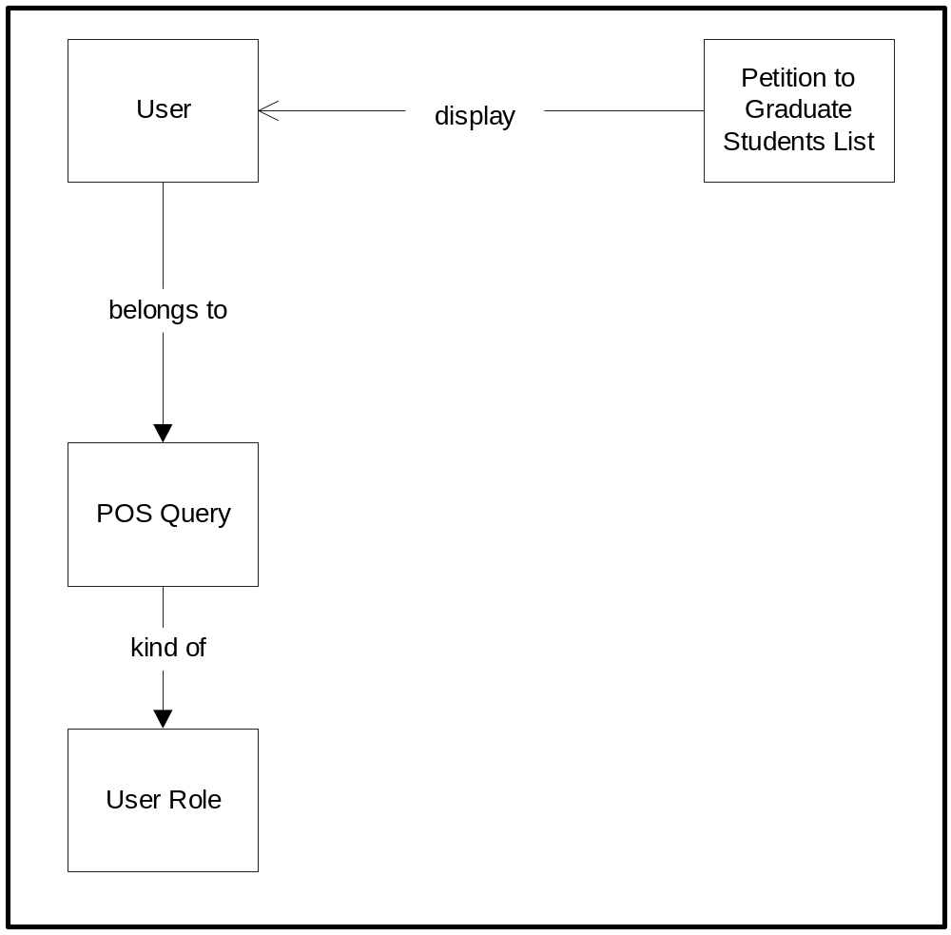 Petition to graduate query

User/actor name

POS Query User
Description
User queries system for students who have petitioned to graduate.
Fit Criterion

The list of students shall include all students that have petitioned to graduate.
Use Case Scenarios
Prerequisite: User created and has POS query role added.
Trigger: Timer expires and system sends electronic communication to “POS query” users that a petition to graduate check should be run.
Note: Inputs allow for multiple selections. (ex. Select all colleges)
- User logs in and has “POS query” role access (input – password).
- User selects to run query for students who have petitioned to graduate.
- User enters semester (required input).
- User enters college (optional input).
- User enters degree type (Bachelor/Masters/PhD) (optional input).
- User enters student type (graduate/undergraduate) (optional input).
- System returns list of students who have petitioned to graduate (output).

User/actor name

Timer
Description
Clear out Graduated Students.
Fit Criterion

The system shall clear graduation petitions each semester.
Use Case Scenarios
- Trigger: A timer is checked by the system for checking all the petitions to graduate.
- The system reviews all the petitions to graduate stored in the Banner database.
- The system clears all the unsuccessful petitions to graduate.
- The system marks/updates all the successful petitions to graduate.
- All student records are updated.

checks

Timer
reviews
All Petitions to Graduate
Banner
Mark/Update
Successful
Petitions to Graduate
Clears
Unsuccessful
Petitions to Graduate
User/actor name

Timer
Description
Update student records with courses and grades.
Fit Criterion

The system shall update student records with courses completed and grades each semester.
Use Case Scenarios
- Trigger: Nightly timer.
- POS System queries banner for any changes to database records of each student.
- POS System updates each student’s program of study when a change is detected in banner.

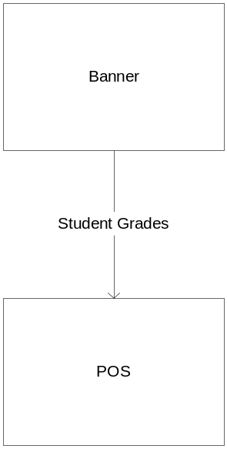

User/actor name

N/A
Description
Protect student records.
Fit Criterion

The system shall protect student records.
Use Case Scenarios
- Trigger: Always.
- All network traffic for the POS is encrypted
- All Student information is password secured
- All updates to the POS are User Permission controlled.

User/actor name

N/A
Description
Change adjacent system or underlying computing technology.
Fit Criterion

The system shall be able to be upgraded to use the new adjacent system or new technology with changes to less than 30% of existing code
Use Case Scenarios
- Trigger: Change made to banner database.
- Determine the scope of the changes made.
- Make changes to existing database interface layer.
- Migrate existing data to new database.
- Verify that modified database interface layer correctly accesses new database.

- Trigger: Change made to underlying server operating system.
- Determine the scope of the changes made.
- Make changes to existing operating system access layer.
- Verify that system executes properly on the new operating system.

- Trigger: Change made to browser.
- Determine the scope of the changes made.
- Make changes to system that utilize browser features not compatible with new browser.
- Integrate new browser into existing system.
- Verify that new browser can access all system developed web pages.

9 Functional and Data Requirements

Requirement #: AAA-001 | Requirement Type: 9 | Event/Use Case #: 1-13
Description: POS system shall identify users by user ID.
Rationale: The system needs to retrieve POS data and system functions based on the current user. A user ID allows for a unique identifier to be created and matched against for retrieving records and assigning roles.
Source: Interview with Registrar assistant
Fit Criterion: Demonstrate that users need to provide a user ID before accessing the system.
Customer Satisfaction: 2 | Customer Dissatisfaction: 3
Dependencies: | Conflicts:
Supporting Materials:
History: Created 3/17/04
Modified 4/9/04

Requirement #: AAA-002 | Requirement Type: 9 | Event/Use Case #: 1-13
Description: POS system shall provide capability for creation of user IDs.
Rationale: In order to add new users to the system, a capability needs to be provided to create user IDs for assignment.
Source: Interview with Registrar assistant
Fit Criterion: Demonstrate that an administrator can create new users and assign them user IDs. Verify that a user can log into the system once the account is created.
Customer Satisfaction: 2 | Customer Dissatisfaction: 3
Dependencies: AAA-004,  AAA-005 | Conflicts:
Supporting Materials:
History: Created 3/17/04
Modified 4/9/04

Requirement #: AAA-003 | Requirement Type: 9 | Event/Use Case #: 1-13
Description: POS system shall provide capability for creation of user roles.
Rationale: The system needs to be able to differentiate different role types in order to group functionality provided to each user. The system cannot anticipate all the future roles needed, so a mechanism to create new roles allows this decision to be made after delivery.
Source: Interview with Registrar assistant
Fit Criterion: Demonstrate that an administrator can create new user roles.
Customer Satisfaction: 2 | Customer Dissatisfaction: 3
Dependencies: | Conflicts:
Supporting Materials:
History: Created 3/17/04
Modified 4/9/04

Requirement #: AAA-004 | Requirement Type: 9 | Event/Use Case #: 1-13
Description: POS system shall allow administrators to associate user roles with a user ID.
Rationale: Once roles and user IDs are created, a mapping needs to be made to determine what role(s) a user can play in the system.
Source: Interview with Registrar assistant
Fit Criterion: Demonstrate that an administrator can associate a user role with a user ID. User roles and user IDs should have been created in verification of other steps.
Customer Satisfaction: 2 | Customer Dissatisfaction: 4
Dependencies: AAA-002, AAA-003 | Conflicts:
Supporting Materials:
History: Created 3/17/04
Modified 4/9/04

Requirement #: AAA-005 | Requirement Type: 9 | Event/Use Case #: 1-13
Description: POS system shall have the following features:
- Create POS Template
- Update POS Template
- Delete POS Template
- Create POS
- Update POS
- Delete POS
- View POS
- Approve POS
- Request POS Approval
- Petition to Graduate
- Outstanding Course List Query
- Create User
- Modify User
- Delete User
- Students who have petitioned to graduate Query
Rationale: These features are the minimum set of features requested by the user’s that have been interviewed as well as in the initial description of the problem being solved.
Source: Interview with Registrar assistant, Dr. Bond (client)
Fit Criterion: Demonstrate that the described features are provided and can be used by a user with proper role.
Customer Satisfaction: 4 | Customer Dissatisfaction: 3
Dependencies: | Conflicts:
Supporting Materials:
History: Created 3/17/04

Requirement #: AAA-006 | Requirement Type: 9 | Event/Use Case #: 1-13
Description: POS system shall allow association of one or more features to a user role.
Rationale: A user can take on more than one role in the system. If this requirement is not implemented then users would need multiple user IDs to perform different functions which is cumbersome.
Source: Interview with Registrar assistant
Fit Criterion: Demonstrate that an administrator can assign one or more features to a role. An assumption is made that features and roles have been created prior to verifying this requirement.
Customer Satisfaction: 4 | Customer Dissatisfaction: 4
Dependencies: AAA-002, AAA-003, AAA-004, AAA-005 | Conflicts:
Supporting Materials:
History: Created 3/17/04
Modified 4/9/04

Requirement #: AAA-007 | Requirement Type: 9 | Event/Use Case #: 1-13
Description: POS system shall require user ID and authentication for access.
Rationale: The system stores confidential and sensitive information. Therefore, the system needs to know who the user is and what that user can do in the system.
Source: Interview with Registrar assistant, Dr. Bond (client), Interview with student coordinator
Fit Criterion: Verify that a user of the system must provide user ID and the system authenticates the user before allowing access to the system.
Customer Satisfaction: 3 | Customer Dissatisfaction: 5
Dependencies: AAA-001 | Conflicts:
Supporting Materials:
History: Created 3/17/04
Modified 4/9/04

Requirement #: AAA-008 | Requirement Type: 9 | Event/Use Case #: 1-13
Description: POS system shall determine if entered user ID is valid.
Rationale: The system needs to know whether the user trying to access the system actually exists in the system.
Source: Interview with Registrar assistant
Fit Criterion: Verify that a valid user is allowed to log into the system. Verify that an invalid user is flagged as invalid by the system.
Customer Satisfaction: 2 | Customer Dissatisfaction: 2
Dependencies: | Conflicts:
Supporting Materials:
History: Created 3/17/04
Modified 4/9/04

Requirement #: AAA-010 | Requirement Type: 9 | Event/Use Case #: 1-13
Description: POS system shall show appropriate selections based on user role.
Rationale: The system needs to tailor appearance based on the role of the user to increase usability.
Source: Interview with Registrar assistant
Fit Criterion: Demonstrate that the interface changes based on user role.
Customer Satisfaction: 2 | Customer Dissatisfaction: 2
Dependencies: AAA-006 | Conflicts:
Supporting Materials:
History: Created 3/17/04
Modified 4/9/04

Requirement #: AAA-011 | Requirement Type: 9 | Event/Use Case #: 1
Description: POS system shall allow users with POS Admin role the ability to create POS templates.
Rationale: A Pos Admin user needs to be able to create new templates when changes in requirements occur or new academic years are added to the university catalog. The system cannot anticipate all the varied templates required so a capability to create new templates is required.
Source: Interview with Registrar assistant
Fit Criterion: Demonstrate that a user with POS Admin role has the ability to create POS templates.
Customer Satisfaction: 4 | Customer Dissatisfaction: 4
Dependencies: None | Conflicts: None
Supporting Materials: None
History: Created 3/17/04

Requirement #: AAA-012 | Requirement Type: 9 | Event/Use Case #: 1-3
Description: POS system shall list all existing POS templates.
Rationale: The POS admin user needs to be able to see if an existing POS template exists or whether a new one needs to be created. By displaying a list of the POS templates, the POS Admin user can make that decision.
Source: Interview with Registrar assistant
Fit Criterion: Demonstrate that the POS system lists all existing POS templates.
Customer Satisfaction: 2 | Customer Dissatisfaction: 3
Dependencies: AAA-011 | Conflicts:
Supporting Materials:
History: Created 3/17/04

Requirement #: AAA-013 | Requirement Type: 9 | Event/Use Case #: 1
Description: POS system shall provide capability to define a default POS template.
Rationale: In order to lower the time required to create new templates, the system needs to pre populate as much information as possible when creating new templates.
Source: Interview with Registrar assistant
Fit Criterion: Demonstrate that the system allows an administrator to create a default POS template. Log in as POS Admin and verify that default POS template is valid.
Customer Satisfaction: 4 | Customer Dissatisfaction: 3
Dependencies: | Conflicts:
Supporting Materials:
History: Created 3/17/04

Requirement #: AAA-014 | Requirement Type: 9 | Event/Use Case #: 1,2
Description: POS system shall provide capability to save a POS template.
Rationale: To be useful, when new POS templates are created, they need to be persisted so that they exist outside of user logins and system reboots.
Source: Interview with Registrar assistant
Fit Criterion: Demonstrate that POS template can be edited and saved. Exit the system, log back into the system and verify that changes are preserved.
Customer Satisfaction: 5 | Customer Dissatisfaction: 5
Dependencies: AAA-054 | Conflicts:
Supporting Materials:
History: Created 3/17/04

Requirement #: AAA-015 | Requirement Type: 9 | Event/Use Case #: 1-3
Description: POS system shall allow users with POS admin role the ability to select POS templates.
Rationale: Selection or modification of POS templates should only be accessed by the appropriate users.
Source: Interview with Registrar assistant
Fit Criterion: Demonstrate that a user with POS admin role can select an existing POS template. Verify that the POS template is displayed with the information that was entered when the template was created.
Customer Satisfaction: 3 | Customer Dissatisfaction: 3
Dependencies: AAA-014 | Conflicts:
Supporting Materials:
History: Created 3/17/04

Requirement #: AAA-016 | Requirement Type: 9 | Event/Use Case #: 1-3
Description: POS system shall display the contents of a selected POS template.
Rationale: Once selected, the system needs to show the user the contents of the POS template so the user can determine whether to make changes to the template.
Source: Interview with Registrar assistant
Fit Criterion: Demonstrate that a user with POS admin role can select an existing POS template. Verify that the POS template is displayed with the information that was entered when the template was created.
Customer Satisfaction: 2 | Customer Dissatisfaction: 3
Dependencies: AAA-014 | Conflicts:
Supporting Materials:
History: Created 3/17/04

Requirement #: AAA-017 | Requirement Type: 9 | Event/Use Case #: 1
Description: Academic year shall be an input for POS template creation.
Rationale: A POS template can change from academic year to academic year so the system needs to associate an academic year with each template.
Source: Interview with Registrar assistant
Fit Criterion: Demonstrate that academic year is an input for creating a POS template.
Customer Satisfaction: 2 | Customer Dissatisfaction: 5
Dependencies: AAA-014, AAA-048, AAA-057 | Conflicts:
Supporting Materials:
History: Created 3/17/04

Requirement #: AAA-018 | Requirement Type: 9 | Event/Use Case #: 1
Description: Academic major shall be an input for POS template creation.
Rationale: Each POS template is tied to a particular major. Without this input, a generic POS template would have to be created that encompassed all majors.
Source: Interview with Registrar assistant
Fit Criterion: Demonstrate that academic major is an input for creating a POS template.
Customer Satisfaction: 4 | Customer Dissatisfaction: 4
Dependencies: AAA-014, AAA-048, AAA-057 | Conflicts:
Supporting Materials:
History: Created 3/17/04

Requirement #: AAA-019 | Requirement Type: 9 | Event/Use Case #: 1
Description: POS system shall display a list of majors for POS template creation.
Rationale: When creating a POS template the user should be presented with a list of majors in order to speed up the process as well as ensure correctness of the POS template.
Source: Interview with Registrar assistant
Fit Criterion: Demonstrate that academic major is selectable list input for creating a POS template.
Customer Satisfaction: 2 | Customer Dissatisfaction: 3
Dependencies: AAA-014, AAA-048, AAA-057 | Conflicts:
Supporting Materials:
History: Created 3/17/04

Requirement #: AAA-020 | Requirement Type: 9 | Event/Use Case #: 1
Description: Academic track/focus shall be an input for POS template creation.
Rationale: A POS template can have multiple tracks and focus areas within a particular major. By having it as an input, the system allows for multiple tracks and focus areas to be defined in the graduation requirements.
Source: Interview with Registrar assistant
Fit Criterion: Demonstrate that academic track/focus is an input for creating a POS template.
Customer Satisfaction: 2 | Customer Dissatisfaction: 3
Dependencies: AAA-014, AAA-048, AAA-057 | Conflicts:
Supporting Materials:
History: Created 3/17/04

Requirement #: AAA-021 | Requirement Type: 9 | Event/Use Case #: 1
Description: POS system shall display a list of track/focus for POS template creation.
Rationale: When creating a POS template the user should be presented with a list of track/focus areas in order to speed up the process as well as ensure correctness of the POS template
Source: Interview with Registrar assistant
Fit Criterion: Demonstrate that track/focus is selectable list input for creating a POS template.
Customer Satisfaction: 2 | Customer Dissatisfaction: 3
Dependencies: AAA-014, AAA-048, AAA-057 | Conflicts:
Supporting Materials:
History: Created 3/17/04

Requirement #: AAA-022 | Requirement Type: 9 | Event/Use Case #: 1
Description: A POS template shall be made up of required courses and elective courses.
Rationale: A POS template has to include required courses and elective courses because all majors have both types of courses in their graduation requirements.
Source: Course Catalog
Fit Criterion: Demonstrate that a POS template contains both required and elective courses. Demonstrate adding a required course. Demonstrate adding an elective course.
Customer Satisfaction: 2 | Customer Dissatisfaction: 5
Dependencies: AAA-014, AAA-048, AAA-057 | Conflicts:
Supporting Materials:
History: Created 3/17/04

Requirement #: AAA-023 | Requirement Type: 9 | Event/Use Case #: 1
Description: Course identification number (CIN) shall be an input for POS template creation.
Rationale: In order for the system to make comparisons, a unique course ID is required.
Source: Course Catalog
Fit Criterion: Demonstrate that CIN is an input for creating a POS template.
Customer Satisfaction: 2 | Customer Dissatisfaction: 3
Dependencies: AAA-014, AAA-048, AAA-057 | Conflicts:
Supporting Materials:
History: Created 3/17/04

Requirement #: AAA-025 | Requirement Type: 9 | Event/Use Case #: 1
Description: The POS system shall provide a capability for defining ranges of CINs for POS template creation.
Rationale: When determining graduation requirements, often elective courses can be from a range of courses. This requirement ensures that the system can provide a capability for defining that range.
Source: Interview with Registrar assistant
Fit Criterion: Demonstrate that a range of CINs can be defined for POS template creation.
Customer Satisfaction: 5 | Customer Dissatisfaction: 5
Dependencies: AAA-014, AAA-048, AAA-057 | Conflicts:
Supporting Materials:
History: Created 3/17/04

Requirement #: AAA-026 | Requirement Type: 9 | Event/Use Case #: 1
Description: The POS system shall provide a capability for defining allowable sets of CINs for POS template creation.
Rationale: When determining graduation requirements, often elective courses can be from a set of courses. This requirement ensures that the system can provide a capability for defining that set.
Source: Interview with Registrar assistant
Fit Criterion: Demonstrate that a set of allowable courses can be created and saved with a POS template.
Customer Satisfaction: 5 | Customer Dissatisfaction: 5
Dependencies: AAA-014, AAA-048, AAA-057 | Conflicts:
Supporting Materials:
History: Created 3/17/04

Requirement #: AAA-027 | Requirement Type: 9 | Event/Use Case #: 1-3
Description: POS templates shall be identified by a unique POS template identifier.
Rationale: In order to save and retrieve POS templates, a unique POS template identifier is required by the system.
Source: Domain Research
Fit Criterion: Demonstrate that an admin can create a POS template, save the template with a POS template identifier, and then retrieve the POS template based on POS template identifier selected. Verify that contents displayed are the same as what was entered.
Customer Satisfaction: 2 | Customer Dissatisfaction: 3
Dependencies: AAA-014, AAA-048, AAA-057 | Conflicts:
Supporting Materials:
History: Created 3/17/04

Requirement #: AAA-028 | Requirement Type: 9 | Event/Use Case #: 2
Description: A POS template identifier shall be an input for saving POS templates.
Rationale: Saving a POS template requires a POS template identifier to determine if the POS template already exists and to prompt the user for overwriting the existing POS template.
Source: Domain Research
Fit Criterion: Demonstrate that an admin can create a POS template, save the template with a POS template identifier, and then retrieve the POS template based on POS template identifier selected. Verify that contents displayed are the same as what was entered.
Customer Satisfaction: 3 | Customer Dissatisfaction: 3
Dependencies: AMK-054 | Conflicts:
Supporting Materials:
History: Created 3/17/04

Requirement #: AAA-029 | Requirement Type: 9 | Event/Use Case #: 1-3
Description: The POS system shall store POS templates in persistent storage.
Rationale: To be useful, POS templates need to be accessed after they have been created. By saving the POS templates to persistent storage, users logging in after the POS template creation can use the data.
Source: Interview with Registrar assistant
Fit Criterion: Demonstrate that an admin can create a POS template, save the template with a POS template identifier, and then retrieve the POS template based on POS template identifier selected. Verify that contents displayed are the same as what was entered.
Customer Satisfaction: 2 | Customer Dissatisfaction: 5
Dependencies: | Conflicts:
Supporting Materials:
History: Created 3/17/04

Requirement #: AAA-030 | Requirement Type: 9 | Event/Use Case #: 1-3
Description: POS system shall allow POS templates to be modified by users with POS Admin role.
Rationale: Only authorized users should be allowed to change POS templates.
Source: Interview with Registrar assistant
Fit Criterion: Demonstrate that a user logged in as POS admin has ability to modify POS templates. Demonstrate that a user logged in without POS admin role cannot change POS templates.
Customer Satisfaction: 2 | Customer Dissatisfaction: 5
Dependencies: | Conflicts:
Supporting Materials:
History: Created 3/17/04

Requirement #: AAA-031 | Requirement Type: 9 | Event/Use Case #: 2
Description: The POS system shall allow selection of saved POS templates based on a template identifier.
Rationale: Need to provide a way to uniquely identify and allow users to select POS templates to view/update.
Source: Interview with Student Coordinator, Domain Research.
Fit Criterion: Demonstrate that an admin can create a POS template, save the template with a POS template identifier, and then retrieve the POS template based on POS template identifier selected. Verify that contents displayed are the same as what was entered.
Customer Satisfaction: 2 | Customer Dissatisfaction: 3
Dependencies: AAA-027, AAA-029 | Conflicts:
Supporting Materials:
History: Created 3/17/04

Requirement #: AAA-032 | Requirement Type: 9 | Event/Use Case #: 2
Description: Academic year shall be an input for POS template modification.
Rationale: The POS template will be based on the major requirements for a specific academic year. Need to be able to specify the year for a given template.
Source: Course Catalog.
Fit Criterion: Demonstrate that an admin can create a POS template. Demonstrate that academic year is an input for POS templates. Save the template with a POS template identifier, and then retrieve the POS template based on POS template identifier selected. Verify that contents displayed are the same as what was entered.
Customer Satisfaction: 2 | Customer Dissatisfaction: 5
Dependencies: AAA-027, AAA-029 | Conflicts:
Supporting Materials: Course Catalog
History: Created 3/17/04

Requirement #: AAA-033 | Requirement Type: 9 | Event/Use Case #: 2
Description: Academic major shall be an input for POS template modification.
Rationale: Each POS template will be based on the major requirements for a specific academic year. Need to be able to specify the major for a given template.
Source: Course Catalog.
Fit Criterion: Demonstrate that an admin can create a POS template. Demonstrate that academic major is an input for POS templates. Save the template with a POS template identifier, and then retrieve the POS template based on POS template identifier selected. Verify that contents displayed are the same as what was entered.
Customer Satisfaction: 2 | Customer Dissatisfaction: 5
Dependencies: AAA-027, AAA-029 | Conflicts:
Supporting Materials: Course Catalog
History: Created 3/17/04

Requirement #: AAA-034 | Requirement Type: 9 | Event/Use Case #: 2
Description: POS system shall display a list of majors for POS template modification.
Rationale: Need to ensure that major selected for a POS template is one that is offered by the school.
Source: Course Catalog.
Fit Criterion: Demonstrate that an admin can create a POS template. Demonstrate that academic major is presented as a list for POS templates. Save the template with a POS template identifier, and then retrieve the POS template based on POS template identifier selected. Verify that contents displayed are the same as what was entered.
Customer Satisfaction: 2 | Customer Dissatisfaction: 4
Dependencies: AAA-027, AAA-029 | Conflicts:
Supporting Materials: Course Catalog
History: Created 3/17/04

Requirement #: AAA-035 | Requirement Type: 9 | Event/Use Case #: 2
Description: The system shall identify courses by a Course Identification Number (CIN).
Rationale: Need to be able to enter courses, identified by CIN, for each POS template to identify required and elective courses.
Source: Course Catalog.
Fit Criterion: Demonstrate that an admin can create a POS template. Demonstrate that CIN is an input for POS templates. Save the template with a POS template identifier, and then retrieve the POS template based on POS template identifier selected. Verify that contents displayed are the same as what was entered.
Customer Satisfaction: 2 | Customer Dissatisfaction: 4
Dependencies: AAA-027, AAA-029 | Conflicts:
Supporting Materials: Course Catalog
History: Created 3/17/04

Requirement #: AAA-036 | Requirement Type: 9 | Event/Use Case #: 2
Description: The POS system shall provide a capability for defining ranges of CINs for POS template modification.
Rationale: Need to be able to enter courses, identified by CIN, for each POS template to identify required and elective courses. Want to be able to specify a range of courses to use for an elective requirement.
Source: Course Catalog.
Fit Criterion: Demonstrate that an admin can create a POS template. Demonstrate that an administrator can create a range of CINs for a POS template. Save the template with a POS template identifier, and then retrieve the POS template based on POS template identifier selected. Verify that contents displayed are the same as what was entered.
Customer Satisfaction: 3 | Customer Dissatisfaction: 3
Dependencies: AAA-027, AAA-029 | Conflicts:
Supporting Materials: Course Catalog, Lists of acceptable electives
History: Created 3/17/04

Requirement #: AAA-037 | Requirement Type: 9 | Event/Use Case #: 2
Description: The POS system shall provide a capability for defining allowable sets of CINs for POS template modification.
Rationale: Need to be able to enter courses, identified by CIN, for each POS template to identify required and elective courses. Want to be able to specify a group of courses to use for an elective requirement, not necessarily with sequential course numbers.
Source: Course Catalog.
Fit Criterion: Demonstrate that an admin can create a POS template. Demonstrate that an administrator can create a set of CINs for a POS template. Save the template with a POS template identifier, and then retrieve the POS template based on POS template identifier selected. Verify that contents displayed are the same as what was entered.
Customer Satisfaction: 3 | Customer Dissatisfaction: 3
Dependencies: AAA-027, AAA-029 | Conflicts:
Supporting Materials: Course Catalog, Lists of acceptable electives
History: Created 3/17/04

Requirement #: AAA-041 | Requirement Type: 9 | Event/Use Case #: 2
Description: The POS system shall notify user before overwriting an existing POS template in persistent storage.
Rationale: Need to be able to update POS templates, but don’t want user to accidentally overwrite an existing template.
Source: Course Catalog, Domain Research.
Fit Criterion: Demonstrate a POS admin logging in and selecting an existing POS template. Demonstrate POS admin making a change to the POS template. Demonstrate POS admin saving the POS template. Verify that system notifies POS admin with a message indicating POS template will be overwritten. Verify that POS admin can override or cancel the warning.
Customer Satisfaction: 3 | Customer Dissatisfaction: 3
Dependencies: AAA-054 | Conflicts:
Supporting Materials:
History: Created 3/17/04

Requirement #: AAA-042 | Requirement Type: 9 | Event/Use Case #: 3
Description: The POS system shall allow for deletion of persistent POS templates.
Rationale: Want to be able to delete POS templates that are no longer needed.
Source: Course Catalog.
Fit Criterion: Demonstrate that when a POS admin user can select a POS template and instruct the system to delete the selected POS template. Demonstrate that deleted POS template is no longer accessible by the POS system.
Customer Satisfaction: 2 | Customer Dissatisfaction: 2
Dependencies: AAA-029, AAA-043 | Conflicts:
Supporting Materials:
History: Created 3/17/04

Requirement #: AAA-043 | Requirement Type: 9 | Event/Use Case #: 3
Description: POS template identifier shall be an input for POS template deletion.
Rationale: Need to be able to uniquely identify a POS template to delete.
Source: Course Catalog, Domain Research.
Fit Criterion: Demonstrate that when a POS admin user can select a POS template and instruct the system to delete the selected POS template based on POS template identifier. Demonstrate that deleted POS template is no longer accessible by the POS system.
Customer Satisfaction: 2 | Customer Dissatisfaction: 2
Dependencies: AAA-029, AAA-042 | Conflicts:
Supporting Materials:
History: Created 3/17/04

Requirement #: AAA-044 | Requirement Type: 9 | Event/Use Case #: 3
Description: POS system shall confirm deletion request from user.
Rationale: Want to be able to delete POS templates that are no longer needed. However, want to make sure templates are not deleted accidentally.
Source: Course Catalog, Domain Research.
Fit Criterion: Demonstrate that when a POS admin user can select a POS template and instruct the system to delete the selected POS template based on POS template identifier. Demonstrate that system prompts user for confirmation of delete request. Demonstrate that deleted POS template is no longer accessible by the POS system.
Customer Satisfaction: 2 | Customer Dissatisfaction: 2
Dependencies: AAA-029, AAA-042 | Conflicts:
Supporting Materials:
History: Created 3/17/04

Requirement #: AAA-045 | Requirement Type: 9 | Event/Use Case #: 3
Description: POS system shall notify user of successful POS template deletion.
Rationale: Want to be able to delete POS templates that are no longer needed. Want to provide indication to the user when this is completed.
Source: Course Catalog, Domain Research.
Fit Criterion: Demonstrate that when a POS admin user can select a POS template and instruct the system to delete the selected POS template based on POS template identifier. Demonstrate that system prompts user for confirmation of delete request. Demonstrate that system notifies operator of deletion status. Demonstrate that deleted POS template is no longer accessible by the POS system.
Customer Satisfaction: 2 | Customer Dissatisfaction: 2
Dependencies: AAA-029 | Conflicts:
Supporting Materials:
History: Created 3/17/04

Requirement #: CCC-2 | Requirement Type: 9 | Event/Use Case #: 7
Description: The POS System shall allow Approvers to access the student POS for each student they advise.
Rationale: Approver (advisor) needs to be able to access the POS for each advisee.
Source: Interview with Student Coordinator.
Fit Criterion: An Approver shall have access to the POS for each associated student/advisee.
Customer Satisfaction: 2 | Customer Dissatisfaction: 5
Dependencies: None | Conflicts: None
Supporting Materials: None
History: Created 3/17/04, Updated 4/4/04

Requirement #: CCC-3 | Requirement Type: 9 | Event/Use Case #: 7
Description: The POS System shall accept a student’s POS selection from the approver.
Rationale: Approver (advisor) needs to be able to access the POS for each advisee.
Source: Interview with Student Coordinator.
Fit Criterion: The recorded POS selection shall match the POS selection from the Approver.
Customer Satisfaction: 2 | Customer Dissatisfaction: 5
Dependencies: None | Conflicts: None
Supporting Materials: None
History: Created 3/17/04, Updated 4/4/04

Requirement #: CCC-5 | Requirement Type: 9 | Event/Use Case #: 7
Description: The POS System shall display selected POS data to the user.
Rationale: Have to display POS data in a format that the user can use.
Source: Interview with Student Coordinator.
Fit Criterion: The displayed POS data shall match the selected student’s record.
Customer Satisfaction: 2 | Customer Dissatisfaction: 5
Dependencies: None | Conflicts: None
Supporting Materials: None
History: Created 3/17/04, Updated 4/4/04

Requirement #: CCC-6 | Requirement Type: 9 | Event/Use Case #: 7
Description: The POS System shall accept a valid academic year from an Approver.
Rationale: Need to be able to set/update the academic year on which a student’s POS is based. A student may move to a newer set of degree requirements.
Source: Interview with Student Coordinator / Bond.
Fit Criterion: The recorded academic year for a POS shall match the year entered by an Approver.
Customer Satisfaction: 2 | Customer Dissatisfaction: 4
Dependencies: None | Conflicts: None
Supporting Materials: Course Catalog
History: Created 3/17/04, Updated 4/4/04

Requirement #: CCC-7 | Requirement Type: 9 | Event/Use Case #: 7
Description: The POS System shall accept a valid major from an Approver.
Rationale: Need to be able to set/update the major on which a student’s POS is based. A student may change major after being admitted.
Source: Interview with Student Coordinator / Bond.
Fit Criterion: The recorded major for a POS shall match the major entered by an Approver.
Customer Satisfaction: 2 | Customer Dissatisfaction: 4
Dependencies: None | Conflicts: None
Supporting Materials: Course Catalog, Change of Major form
History: Created 3/17/04, Updated 4/4/04

Requirement #: CCC-8 | Requirement Type: 9 | Event/Use Case #: 7
Description: The POS System shall accept a valid track/focus from a User.
Rationale: Need to be able to set/update the track/focus on which a student’s POS is based.
Source: Interview with Student Coordinator, Course catalog.
Fit Criterion: The recorded track/focus for a POS shall match the track/focus entered by an Approver.
Customer Satisfaction: 2 | Customer Dissatisfaction: 4
Dependencies: None | Conflicts: None
Supporting Materials: Course Catalog, Program Plan
History: Created 3/17/04, Updated 4/4/04

Requirement #: CCC-9 | Requirement Type: 9 | Event/Use Case #: 7
Description: The POS System shall accept a valid elective from a User.
Rationale: Need to be able to set/update a selected elective for a student’s POS.
Source: Interview with Student Coordinator, Course catalog.
Fit Criterion: The recorded electives for a POS shall match the electives entered by an Approver.
Customer Satisfaction: 2 | Customer Dissatisfaction: 4
Dependencies: None | Conflicts: None
Supporting Materials: Course Catalog, POS
History: Created 3/17/04, Updated 4/4/04

Requirement #: CCC-10 | Requirement Type: 9 | Event/Use Case #: 7
Description: The POS System shall accept a substitute course in place of a required course from an Approver.
Rationale: Need to be able to substitute a course for a required one, in case the student has already taken an acceptable substitute, required course is not offered, etc.
Source: Interview with Student Coordinator, Bond.
Fit Criterion: A recorded substitute course for a POS shall match the substitute course entered by an Approver.
Customer Satisfaction: 2 | Customer Dissatisfaction: 5
Dependencies: None | Conflicts: None
Supporting Materials: Course Catalog, Substitute Course form
History: Created 3/17/04, Updated 4/4/04

Requirement #: CCC-11 | Requirement Type: 9 | Event/Use Case #: 7
Description: The POS System shall save user’s changes to a POS upon request.
Rationale: Need to be able to save changes that are made to a POS.
Source: Interview with Student Coordinator.
Fit Criterion: The retrieved POS data shall match the POS data saved by the user.
Customer Satisfaction: 2 | Customer Dissatisfaction: 5
Dependencies: None | Conflicts: None
Supporting Materials: None
History: Created 3/17/04, Updated 4/4/04

Requirement #: MTS-001 | Requirement Type: 9 | Event/Use Case #: 4
Description: The system shall use electronic communication to inform users to review the next semester course selections.
Rationale: The old method had no way to inform the users when to review courses.
Source: Domain Research
Fit Criterion: Confirm that electronic communication is used to inform users to review the next semester course selections.
Customer Satisfaction: 3 | Customer Dissatisfaction: 2
Dependencies: | Conflicts:
Supporting Materials:
History: Created 3/9/04

Requirement #: MTS-002 | Requirement Type: 9 | Event/Use Case #: 4
Description: The system shall use a timer to trigger.
Rationale: There needs to be a timer for the automatic functions
Source: Domain Research
Fit Criterion: Confirm that the system is using a timer to trigger automatic functions.
Customer Satisfaction: 1 | Customer Dissatisfaction: 2
Dependencies: | Conflicts:
Supporting Materials:
History: Created 3/9/04

Requirement #: MTS-003 | Requirement Type: 9 | Event/Use Case #: 4
Description: The system shall provide different user roles
Rationale: Roles provide a way to partition users for the various tasks of the system.
Source: Domain Research
Fit Criterion: Confirm that the system provides different user roles.
Customer Satisfaction: 3 | Customer Dissatisfaction: 4
Dependencies: | Conflicts:
Supporting Materials:
History: Created 3/9/04

Requirement #: MTS-004 | Requirement Type: 9 | Event/Use Case #: 4
Description: User roles shall include the following:
- POS query role.
- Student
- POS Approver.
Rationale: These are the roles needed by the use cases.
Source: Dr. Bond/Interviews
Fit Criterion: Confirm that the following user roles are provided:
- POS query role.
- Student
- POS Approver
Customer Satisfaction: 3 | Customer Dissatisfaction: 4
Dependencies: MTS-003 | Conflicts:
Supporting Materials:
History: Created 3/9/04

Requirement #: MTS-005 | Requirement Type: 9 | Event/Use Case #: 4
Description: The system shall provide an Outstanding Course list.
Rationale: This is a feature to assist with the next semester course selection.
Source: Dr. Bond
Fit Criterion: Confirm that an Outstanding Course list feature is provided.
Customer Satisfaction: 3 | Customer Dissatisfaction: 2
Dependencies: | Conflicts:
Supporting Materials:
History: Created 3/9/04

Requirement #: MTS-006 | Requirement Type: 9 | Event/Use Case #: 4
Description:. The “Outstanding Course List” shall include the following:
- The courses needed for next semester.
- The number of students that require each course
Rationale: This is the information that the “Outstanding Course List” feature must provide in order to be useful.
Source: Dr. Bond
Fit Criterion: Confirm that the Outstanding Course List includes the following:
- The courses needed for next semester.
- The number of students that require each course
Customer Satisfaction: 3 | Customer Dissatisfaction: 2
Dependencies: MTS-005 | Conflicts:
Supporting Materials:
History: Created 3/9/04

Requirement #: MTS-007 | Requirement Type: 9 | Event/Use Case #: 4
Description: The system shall provide a method for a user to select the “Outstanding Course List”.
Rationale: There has to be a way for the user to select the feature
Source: Domain Research
Fit Criterion: Confirm that the system has a method for a user to select the Outstanding Course List feature.
Customer Satisfaction: | Customer Dissatisfaction:
Dependencies: MTS-005 | Conflicts:
Supporting Materials:
History: Created 3/9/04

Requirement #: MTS-008 | Requirement Type: 9 | Event/Use Case #: 4
Description: The system shall require a user to have the “POS query” role in order to access the Outstanding course list.
Rationale: Access need to limited to a more trusted roles
Source: Dr. Bond
Fit Criterion: Confirm that only users with the POS query role are able to access the Outstanding Course List feature.
Customer Satisfaction: 2 | Customer Dissatisfaction: 4
Dependencies: MTS-005, MTS-004 | Conflicts:
Supporting Materials:
History: Created 3/9/04

Requirement #: MTS-009 | Requirement Type: 9 | Event/Use Case #: 4
Description: The system shall provide the user the means to configure the “Outstanding Course List” query.
Rationale: There needs to be a way for the user to create the query.
Source: Domain Research
Fit Criterion: Confirm that the system provides the user a means to configure the Outstanding Course List feature.
Customer Satisfaction: 2 | Customer Dissatisfaction: 4
Dependencies: MTS-005 | Conflicts:
Supporting Materials:
History: Created 3/9/04

Requirement #: MTS-010 | Requirement Type: 9 | Event/Use Case #: 4
Description: The “Outstanding Course List” shall be capable of being configured by the following:
- College
- Department
- Student Type (Undergraduate/Graduate)
Rationale: These are the items that a user would query a database in order to find the lists that would be of interest.
Source: Dr. Bond
Fit Criterion: Confirm that the Outstanding Course List query can be configured by the following:
- College
- Department
- Student Type (Undergraduate/Graduate)
Customer Satisfaction: 3 | Customer Dissatisfaction: 4
Dependencies: MTS-005 | Conflicts:
Supporting Materials:
History: Created 3/9/04

Requirement #: MTS-011 | Requirement Type: 9 | Event/Use Case #: 4
Description: Each “Outstanding Course List” configuration item listed in MTS –010 shall be optional for the user.
Rationale: This allows the user to create broader lists
Source: Domain Research
Fit Criterion: Confirm that each “Outstanding Course List” query configuration item listed in MTS –010 is optional for the user
Customer Satisfaction: 2 | Customer Dissatisfaction: 3
Dependencies: | Conflicts:
Supporting Materials:
History: Created 3/9/04

Requirement #: MTS-012 | Requirement Type: 9 | Event/Use Case #: 5
Description: The system shall provide a method to automatically create a POS for a new student.
Rationale: One of the product goals is reduction of time spent in the advisement process. This requirement will help the product meet that goal.
Source: Domain Research
Fit Criterion: Confirm that when a new student is added to the banner database that the system automatically creates a POS for that student.
Customer Satisfaction: 3 | Customer Dissatisfaction: 2
Dependencies: | Conflicts:
Supporting Materials:
History: Created 3/9/04

Requirement #: MTS-013 | Requirement Type: 9 | Event/Use Case #: 5
Description: POS Creation shall be invoked by a timer.
Rationale: Timed checks will be more efficient than manual checks or checks done on every commit to Banner.
Source: Domain Research
Fit Criterion: Confirm that POS creation is invoked by a timer.
Customer Satisfaction: 2 | Customer Dissatisfaction: 3
Dependencies: MTS-012 | Conflicts:
Supporting Materials:
History: Created 3/9/04

Requirement #: MTS-014 | Requirement Type: 9 | Event/Use Case #: 5
Description: The system shall detect a new student that has been added to banner.
Rationale: This is needed for MTS-012
Source: Domain Research
Fit Criterion: Confirm that the system detects when a new student is added to banner.
Customer Satisfaction: 2 | Customer Dissatisfaction: 3
Dependencies: MTS-012 | Conflicts:
Supporting Materials:
History: Created 3/9/04

Requirement #: MTS-015 | Requirement Type: 9 | Event/Use Case #: 5
Description: The system shall retrieve the following information from banner for each new student:
- Name
- Student Number
- Major Code
Rationale: This is needed for MTS-012
Source: Domain Research
Fit Criterion: Confirm that the system retrieves the following information from banner for each new student:
- Name
- Student Number
- Major Code
Customer Satisfaction: 2 | Customer Dissatisfaction: 3
Dependencies: MTS-012 | Conflicts:
Supporting Materials:
History: Created 3/9/04

Requirement #: MTS-016 | Requirement Type: 9 | Event/Use Case #: 5
Description: The system shall use the information from MTS –015 to create a default POS for each new student detected.
Rationale: This is needed for MTS-012
Source: Domain Research
Fit Criterion: Confirm that the default POS created for a new student contains the information from MTS-015
Customer Satisfaction: 2 | Customer Dissatisfaction: 3
Dependencies: MTS-012 | Conflicts:
Supporting Materials:
History: Created 3/9/04

Requirement #: MTS-017 | Requirement Type: 9 | Event/Use Case #: 6
Description: The system shall require a user to have the Student or POS Approver role to edit a POS.
Rationale: An Advisor and Student should be the only one allowed to edit a POS.
Source: Dr. Bond
Fit Criterion: Confirm that only users with Student or POS Approver role can edit a POS.
Customer Satisfaction: 3 | Customer Dissatisfaction: 4
Dependencies: MTS-018 | Conflicts:
Supporting Materials:
History: Created 3/9/04

Requirement #: MTS-018 | Requirement Type: 9 | Event/Use Case #: 6
Description: The system shall provide a method for a user to edit a POS.
Rationale: This is one of the goals of the product.
Source: Domain Research
Fit Criterion: Confirm that a POS can be edited by the system.
Customer Satisfaction: 2 | Customer Dissatisfaction: 5
Dependencies: None | Conflicts: None
Supporting Materials: None
History: Created 3/9/04

Requirement #: MTS-019 | Requirement Type: 9 | Event/Use Case #: 6
Description: The system shall provide a method for a user to select to Edit a POS.
Rationale: There has to be a way for the user to select the feature
Source: Domain Research
Fit Criterion: Confirm that the user can select to edit a POS.
Customer Satisfaction: 2 | Customer Dissatisfaction: 5
Dependencies: MTS-018 | Conflicts:
Supporting Materials:
History: Created 3/9/04

Requirement #: MTS-020 | Requirement Type: 9 | Event/Use Case #: 6
Description: The system shall provide users with the POS Approver role a method to select an individual students POS to edit.
Rationale: A POS Approver would be an advisor. Each advisor would have multiple students. The advisor will need a way to select the student he/she is interested in.
Source: Domain Research
Fit Criterion: Confirm that the system provides users with the POS Approver role a method to select a students POS to edit
Customer Satisfaction: 3 | Customer Dissatisfaction: 5
Dependencies: MTS-018 | Conflicts:
Supporting Materials:
History: Created 3/9/04

Requirement #: MTS-021 | Requirement Type: 9 | Event/Use Case #: 6
Description: The system shall limit users with the Student role to edit only their POS.
Rationale: For privacy reasons, students can only edit their own POS.
Source: interviews
Fit Criterion: Confirm that users with the Student role can only edit their POS.
Customer Satisfaction: 2 | Customer Dissatisfaction: 5
Dependencies: MTS-018 | Conflicts:
Supporting Materials:
History: Created 3/9/04

Requirement #: MTS-023 | Requirement Type: 9 | Event/Use Case #: 6
Description: The system shall be able to save an edited POS.
Rationale: There has to be a way to commit the changes when they are made.
Source: Domain Research
Fit Criterion: When a user selects to save their edits, confirm the edits have actually been saved. 100% of 10 attempts to save should be successful.
Customer Satisfaction: 2 | Customer Dissatisfaction: 5
Dependencies: MTS-018 | Conflicts:
Supporting Materials:
History: Created 3/9/04

Requirement #: MTS-024 | Requirement Type: 9 | Event/Use Case #: 6
Description: The system shall provide a method for a user to view (read-only) a POS.
Rationale: This is one of the goals of the product.
Source: Dr. Bond
Fit Criterion: Confirm that there is a method to view a POS.
Customer Satisfaction: 3 | Customer Dissatisfaction: 5
Dependencies: | Conflicts:
Supporting Materials:
History: Created 3/9/04

Requirement #: MTS-025 | Requirement Type: 9 | Event/Use Case #: 6
Description: The system shall require a user to have the Student or POS Approver role to view a POS.
Rationale: An Advisor and Student should be the only one allowed to view a POS.
Source: Dr. Bond
Fit Criterion: Confirm that the system requires a user to have the Student or POS Approver role to view a POS.
Customer Satisfaction: 2 | Customer Dissatisfaction: 4
Dependencies: MTS-024 | Conflicts:
Supporting Materials:
History: Created 3/9/04

Requirement #: MTS-026 | Requirement Type: 9 | Event/Use Case #: 6
Description: The system shall provide a method for a user to select to View a POS.
Rationale: There has to be a way for the user to select the feature
Source: Domain Research
Fit Criterion: Confirm that the system provides a method for a user to select to View a POS.
Customer Satisfaction: 2 | Customer Dissatisfaction: 5
Dependencies: MTS-024 | Conflicts:
Supporting Materials:
History: Created 3/9/04

Requirement #: MTS-027 | Requirement Type: 9 | Event/Use Case #: 6
Description: The system shall provide users with the POS Approver role a method to select a students POS to view.
Rationale: A POS Approver would be an advisor. Each advisor would have multiple students. The advisor will need a way to select the student he/she is interested in.
Source: Domain Research
Fit Criterion: Confirm that the system provides users with the POS Approver role a method to select a student’s POS to view.
Customer Satisfaction: 2 | Customer Dissatisfaction: 5
Dependencies: MTS-024 | Conflicts:
Supporting Materials:
History: Created 3/9/04

Requirement #: MTS-028 | Requirement Type: 9 | Event/Use Case #: 6
Description: The system shall limit users with the Student role to view only their POS
Rationale: For privacy reasons, students can only view their own POS.
Source: interviews
Fit Criterion: Confirm that users with the Student role can only view their POS.
Customer Satisfaction: 2 | Customer Dissatisfaction: 5
Dependencies: MTS-024 | Conflicts:
Supporting Materials:
History: Created 3/9/04

Requirement #: MMP-001 | Requirement Type: 9 | Event/Use Case #: 10
Description: POS system shall require user ID and password for access.
Rationale: To identify the user of the system.
Source: Documentation and Interview
Fit Criterion: The system shall accept and verify 100 % of the input IDs and passwords.
Customer Satisfaction: 5 | Customer Dissatisfaction: 5
Dependencies: None | Conflicts: None
Supporting Materials:
History: Created 3/20/04
Modified: 4/5/04

Requirement #: MMP-002 | Requirement Type: 9 | Event/Use Case #: 10
Description: The POS system shall determine if entered user ID is valid.
Rationale: To verify the authenticity of the user.
Source: Documentation.
Fit Criterion: The input ID will be compared to the user records by the system for 100 % of the cases
Customer Satisfaction: 5 | Customer Dissatisfaction: 4
Dependencies: MMP-01 | Conflicts: None
Supporting Materials:
History: Created 3/20/04
Modified: 4/5/04
Modified: 4/21/04

Requirement #: MMP-003 | Requirement Type: 9 | Event/Use Case #: 10
Description: The POS system shall determine if entered password is valid.
Rationale: To verify the information entered by the user.
Source: Domain research.
Fit Criterion: The input password will be compared to the stored password for the user in 100% of the cases
Customer Satisfaction: 5 | Customer Dissatisfaction: 5
Dependencies: MMP-01 | Conflicts: None
Supporting Materials:
History: Created 3/20/04
Modified: 4/5/04
Modified: 4/21/04

Requirement #: MMP-004 | Requirement Type: 9 | Event/Use Case #: 10
Description: The POS system shall show appropriate selections based on user role.
Rationale: To verify the actions that can be performed by the user.
Source: Domain research and interviews.
Fit Criterion: The system will verify user information and enable/disable permissions for 95% of the login attempts made by the user.
Customer Satisfaction: 4 | Customer Dissatisfaction: 4
Dependencies: None | Conflicts: None
Supporting Materials:
History: Created 3/20/04
Modified: 4/5/04
Modified: 4/21/04

Requirement #: MMP-005 | Requirement Type: 9 | Event/Use Case #: 10
Description: The POS system shall accept a POS (document, graphic input, table etc.) validated according to a POS template.
Rationale: To process the information provided by the user.
Source: Interviews.
Fit Criterion: The system will display the option of submitting a POS and accept user input for 95% of the acceptable times.
Customer Satisfaction: 5 | Customer Dissatisfaction: 4
Dependencies: None | Conflicts: None
Supporting Materials:
History: Created 3/20/04
Modified: 4/5/04
Modified: 4/21/04

Requirement #: MMP-006 | Requirement Type: 9 | Event/Use Case #: 10
Description: The POS system shall ask for confirmation to submit the POS by using a dialog box.
Rationale: To prompt user before accepting the input.
Source: Domain Research.
Fit Criterion: The system will display appropriate message and prompt user to make a choice for 100% of the times that this event is executed.
Customer Satisfaction: 3 | Customer Dissatisfaction: 3
Dependencies: MMP-05 | Conflicts: None
Supporting Materials:
History: Created 3/20/04
Modified: 4/5/04
Modified: 4/21/04

Requirement #: MMP-007 | Requirement Type: 9 | Event/Use Case #: 10
Description: POS System shall retrieve student information from Banner.
Rationale: To access the student records and comparison.
Source: Documentation.
Fit Criterion: The system shall be able to resolve the internal data for 95% of the time that a query has been made to the Banner database.
Customer Satisfaction: 3 | Customer Dissatisfaction: 2
Dependencies: None | Conflicts: None
Supporting Materials:
History: Created 3/20/04
Modified: 4/5/04
Modified: 4/21/04

Requirement #: MMP-008 | Requirement Type: 9 | Event/Use Case #: 10
Description: The POS system shall notify the user about success or failure of submission with an electronic notification (e-mail, dialog box, screen etc.)
Rationale: To communicate the success or failure of the transaction to the user.
Source: Domain research and Interviews.
Fit Criterion: The system shall generate an electronic notification for 100% of the users who submit a POS for approval.
Customer Satisfaction: 5 | Customer Dissatisfaction: 3
Dependencies: None | Conflicts: None
Supporting Materials:
History: Created 3/20/04
Modified: 4/5/04
Modified: 4/21/04

Requirement #: MMP-009 | Requirement Type: 9 | Event/Use Case #: 10
Description: The POS shall notify the approver by electronic notification about the submission (e-mail etc.)
Rationale: To communicate to the approver about pending application.
Source: Interviews.
Fit Criterion: The system will generate an electronic notification for 100% of the POS that are submitted to the approver.
Customer Satisfaction: 5 | Customer Dissatisfaction: 3
Dependencies: None | Conflicts: None
Supporting Materials:
History: Created 3/20/04
Modified: 4/5/04
Modified: 4/21/04

Requirement #: MMP-010 | Requirement Type: 9 | Event/Use Case #: 10
Description: The electronic notification in MMP-09 shall contain:
- Student ID
- Student Name in Full
- Student Major
- Student Standing
- Student POS to be approved
Rationale: To ensure full data entry by the user.
Source: Documentation and Paper-based application.
Fit Criterion: At least 95% of the users polled for electronic notification will confirm the above-mentioned fields.
Customer Satisfaction: 4 | Customer Dissatisfaction: 3
Dependencies: MMP-09 | Conflicts: None
Supporting Materials:
History: Created 3/20/04
Modified: 4/5/04
Modified: 4/21/04

Requirement #: MMP-011 | Requirement Type: 9 | Event/Use Case #: 11
Description: The POS system shall satisfy MMP-09 and MMP-10.
Rationale: To ensure that a POS has been submitted for approval.
Source: Interviews.
Fit Criterion: : At least 95% of the users polled for electronic notification will confirm the events mentioned in MMP-009 and MMP-010
Customer Satisfaction: 4 | Customer Dissatisfaction:3
Dependencies: MMP-009, MMP-010 | Conflicts: None
Supporting Materials:
History: Created: 3/20/04
Modified: 4/5/04
Modified: 4/21/04

Requirement #: MMP-012 | Requirement Type: 9 | Event/Use Case #: 11
Description: The POS system shall satisfy MMP-01, 02, 03, 04
Rationale: To ensure data integrity and user identification.
Source: Domain research.
Fit Criterion: The system will satisfy the above-mentioned requirements for 100% of the attempted logins.
Customer Satisfaction: 5 | Customer Dissatisfaction: 5
Dependencies: MMP-001,002,003,004 | Conflicts: None
Supporting Materials:
History: Created 3/20/04
Modified: 4/5/04
Modified: 4/21/04

Requirement #: MMP-013 | Requirement Type: 9 | Event/Use Case #: 11
Description: The POS system shall verify the following information:
- Student ID
- Student Name in Full
- Student Major
- Student Standing
- Student Courses
- Student Grades
Rationale: To ensure that all data is correct and the system can proceed with the POS.
Source: Domain Research.
Fit Criterion: The system shall verify at least 99% of the times that information is input into the system.
Customer Satisfaction: 4 | Customer Dissatisfaction: 3
Dependencies: None | Conflicts: None
Supporting Materials:
History: Created 3/21/04
Modified: 4/5/04
Modified: 4/21/04

Requirement #: MMP-014 | Requirement Type: 9 | Event/Use Case #: 11
Description: The POS system shall indicate to approver if POS is verified.
Rationale: To allow user/approver to proceed with the POS application.
Source: Domain research.
Fit Criterion: The system shall generate appropriate message for at least 95% of the time that users are polled for immediate response.
Customer Satisfaction: 5 | Customer Dissatisfaction: 4
Dependencies: None | Conflicts: None
Supporting Materials:
History: Created 3/21/04
Modified: 4/5/04
Modified: 4/21/04

Requirement #: MMP-015 | Requirement Type: 9 | Event/Use Case #: 11
Description: The POS system shall allow approver to enter electronic notification to student in case of rejection.
Rationale: To communicate the reasons for failure to the student/user.
Source: Domain Research and Interviews.
Fit Criterion: The system shall respond with an electronic notification for at least 95% of the time immediately in case of rejection.
Customer Satisfaction: 4 | Customer Dissatisfaction: 3
Dependencies: None | Conflicts: None
Supporting Materials:
History: Created 3/21/04
Modified: 4/5/04
Modified: 4/21/04

Requirement #: MMP-016 | Requirement Type: 9 | Event/Use Case #: 11
Description: If MMP-014 is satisfied, the POS shall update the student flowchart with information from MMP-013.
Rationale: To update the student record and process POS.
Source: Interviews.
Fit Criterion: The users will be provided with an auto-generated flow chart, at least 90% of the time when they wish to see it.
Customer Satisfaction: 4 | Customer Dissatisfaction: 3
Dependencies: MMP-013, 014 | Conflicts: None
Supporting Materials:
History: Created 3/21/04
Modified: 4/5/04
Modified: 4/21/04

Requirement #: MMP-017 | Requirement Type: 9 | Event/Use Case #: 11
Description: The POS system shall update the student record with information as mentioned in MMP-013.
Rationale: To update the student record and process the POS.
Source: Interviews
Fit Criterion: The system shall be able to resolve the internal data for 95% of the time that a query has been made to the Banner database.
Customer Satisfaction: 3 | Customer Dissatisfaction: 2
Dependencies: MMP-013 | Conflicts: None
Supporting Materials:
History: Created 3/21/04
Modified: 4/5/04
Modified: 4/21/04

Requirement #: MMP-018 | Requirement Type: 9 | Event/Use Case #: 11
Description: The POS system shall dispatch an electronic notification (e-mail etc.) to the student indicating POS approval.
Rationale: To communicate the success of approved POS.
Source: Interviews.
Fit Criterion: The system shall generate an electronic notification for 100% of the users whose POS was approved successfully.
Customer Satisfaction: 5 | Customer Dissatisfaction: 5
Dependencies: None | Conflicts: None
Supporting Materials:
History: Created 3/21/04
Modified: 4/5/04

Requirement #: MMP-019 | Requirement Type: 9 | Event/Use Case #: 12
Description: The POS system shall satisfy MMP-01, 02, 03, 04.
Rationale: To ensure data integrity and user identification.
Source: Domain Research.
Fit Criterion: The system will satisfy the above-mentioned requirements for 100% of the attempted logins.
Customer Satisfaction: 5 | Customer Dissatisfaction: 5
Dependencies: MMP-01, 02, 03, 04. | Conflicts: None
Supporting Materials:
History: Created 3/21/04
Modified: 4/5/04
Modified: 4/21/04

Requirement #: MMP-021 | Requirement Type: 9 | Event/Use Case #: 12
Description: The POS system shall retrieve student name, student address and student telephone from student records.
Rationale: To assist user in creating an accurate graduation petition.
Source: Interviews.
Fit Criterion: The system shall be able to retrieve the above-mentioned information for at least 90% of the time that the request has been made.
Customer Satisfaction: 3 | Customer Dissatisfaction: 3
Dependencies: None | Conflicts: None
Supporting Materials:
History: Created 3/21/04
Modified: 4/6/04
Modified: 4/21/04

Requirement #: MMP-022 | Requirement Type: 9 | Event/Use Case #: 12
Description: The POS system shall accept the following inputs in the Petition To Graduate (PTG):
- Intended semester for graduation
- Intended major for graduation
- Major Code
- Student Sex
- Student Height (ft. and inches)
- Student Weight (lbs)
- Student Cap Size (X-small, Small, Medium, Large, X-Large)
- Optional Section for graduate students will include:
        - Previous Degree (Undergraduate and Graduate)
      - Option to attend commencement
Rationale: To obtain mandatory information for the graduation candidate.
Source: Documentation.
Fit Criterion: The PTG screen shall be described as containing above-mentioned fields by 95% of the polled users.
Customer Satisfaction: | Customer Dissatisfaction:
Dependencies: None | Conflicts: None
Supporting Materials:
History: Created 3/21/04
Modified: 4/6/04
Modified: 4/21/04

Requirement #: MMP-023 | Requirement Type: 9 | Event/Use Case #: 12
Description: The POS system shall verify all the entries in the Petition To Graduate (PTG):.
Rationale: To ensure data integrity and accuracy.
Source: Domain Research.
Fit Criterion: The system shall correctly co-relate and verify the input information for 100% of the PTGs that may be input in the system.
Customer Satisfaction: 4 | Customer Dissatisfaction: 3
Dependencies: None | Conflicts: None
Supporting Materials:
History: Created 3/21/04
Modified: 4/6/04
Modified: 4/21/04

Requirement #: MMP-024 | Requirement Type: 9 | Event/Use Case #: 12
Description: Based on MMP-23, the POS system shall dispatch an electronic notification to the student for successful application.
Rationale: To communicate successful submission to the user/student.
Source: Interviews and Domain Research.
Fit Criterion: The system shall respond with an electronic notification for at least 95% of the time immediately in case of success.
Customer Satisfaction: 5 | Customer Dissatisfaction: 4
Dependencies: MMP-023 | Conflicts: None
Supporting Materials:
History: Created: 3/21/04
Modified: 4/6/04
Modified: 4/21/04

Requirement #: MMP-025 | Requirement Type: 9 | Event/Use Case #: 12
Description: The POS system shall send out electronic notification to following users:
- POS admin (rwx access)
- POS viewers (read access only)
- POS approver(rwx access)
- POS query makers (read access only)
Rationale: To notify the users about incumbent Petition To Graduate (PTG).
Source: Interviews.
Fit Criterion: The system will display appropriate message or deliver appropriate message to the above mentioned users for at least 99% of the time based on polled users.
Customer Satisfaction: 4 | Customer Dissatisfaction: 4
Dependencies: None | Conflicts: None
Supporting Materials:
History: Created 3/21/04
Modified: 4/6/04
Modified: 4/21/04

Requirement #: MMP-026 | Requirement Type: 9 | Event/Use Case #: 12
Description: Based on MMP-23, the POS system shall dispatch an electronic notification to student for unsuccessful application.
Rationale: To communicate the failure of application.
Source: Interviews.
Fit Criterion: The system shall respond with an electronic notification for at least 95% of the time immediately in case of failure.
Customer Satisfaction: 5 | Customer Dissatisfaction: 4
Dependencies: MMP-023 | Conflicts: None
Supporting Materials:
History: Created 3/21/04
Modified: 4/6/04
Modified: 4/21/04

Requirement #: MMP-028 | Requirement Type: 9 | Event/Use Case #: 12
Description: The POS system shall satisfy MMP-17.
Rationale: To update the student record and process the petition to graduate.
Source: Interviews.
Fit Criterion: The system shall be able to retrieve the above-mentioned information for at least 90% of the time that the request has been made.
Customer Satisfaction: 3 | Customer Dissatisfaction: 3
Dependencies: MMP-028 | Conflicts: None
Supporting Materials:
History: Created 3/21/04
Modified: 4/6/04
Modified: 4/21/04

Requirement #: YF-001 | Requirement Type: 9 | Event/Use Case #: 13
Description: The POS System shall allow authorized users to query the system for students who have petitioned to graduate.

Rationale: User queries system for students who have petitioned to graduate.
Source: Catalog, Florida Institute of Technology
Fit Criterion: The system will display an input for the petition to graduate and provide appropriate options.
Customer Satisfaction: | Customer Dissatisfaction:
Dependencies: | Conflicts:
Supporting Materials: Mastering the Requirements Process
History: Created 3/22/04

Requirement #: YF-002 | Requirement Type: 9 | Event/Use Case #: 13
Description: The POS System shall accept a semester as an input to query the system for students who have petitioned to graduate.

Rationale: User queries system for students who have petitioned to graduate.
Source: Catalog, Florida Institute of Technology
Fit Criterion: The system will display an input for the petition to graduate and provide appropriate options.
Customer Satisfaction: | Customer Dissatisfaction:
Dependencies: | Conflicts:
Supporting Materials: Mastering the Requirements Process
History: Created 3/22/04

Requirement #: YF-003 | Requirement Type: 9 | Event/Use Case #: 13
Description: The POS System shall allow an authorized user to filter the list of students who have petitioned to graduate based on:
- College
- Degree Type
- Student Type (undergraduate/graduate)

Rationale: User queries system for students who have petitioned to graduate.
Source: Catalog, Florida Institute of Technology
Fit Criterion: The system will display a form with the above-mentioned details.
Customer Satisfaction: | Customer Dissatisfaction:
Dependencies: | Conflicts:
Supporting Materials: Mastering the Requirements Process
History: Created 3/22/04

Requirement #: YF-004 | Requirement Type: 9 | Event/Use Case #: 13
Description: The POS system shall output the list of students who have petitioned to graduate based on the specified criteria.

Rationale: User queries system for students who have petitioned to graduate.
Source: Catalog, Florida Institute of Technology
Fit Criterion: The system will display an input for the petition to graduate and provide appropriate options.
Customer Satisfaction: | Customer Dissatisfaction:
Dependencies: | Conflicts:
Supporting Materials: Mastering the Requirements Process
History: Created 3/22/04

Requirement #: YF-005 | Requirement Type: 9 | Event/Use Case #: 14
Description: The POS system shall allow authorized users to schedule when to clear out graduated students from the POS system.

Rationale: Clear out Graduated Students
Source: Catalog, Florida Institute of Technology
Fit Criterion: The system will generate an exception in case of incorrect information.
Customer Satisfaction: | Customer Dissatisfaction:
Dependencies: | Conflicts:
Supporting Materials: Mastering the Requirements Process
History: Created 3/22/04

Requirement #: YF-006 | Requirement Type: 9 | Event/Use Case #: 14
Description: The POS system shall access Banner to find out if a student has graduated.

Rationale: Clear out Graduated Students
Source: Catalog, Florida Institute of Technology
Fit Criterion: The system will display an input for the petition to graduate and provide appropriate options.
Customer Satisfaction: | Customer Dissatisfaction:
Dependencies: | Conflicts:
Supporting Materials: Mastering the Requirements Process
History: Created 3/22/04

Requirement #: YF-007 | Requirement Type: 9 | Event/Use Case #: 14
Description: The POS system shall clear unsuccessful petitions to graduate.

Rationale: Clear out Graduated Students
Source: Catalog, Florida Institute of Technology
Fit Criterion: The system shall generate an email to the user and update student records.
Customer Satisfaction: | Customer Dissatisfaction:
Dependencies: | Conflicts:
Supporting Materials: Mastering the Requirements Process
History: Created 3/22/04

Requirement #: YF-008 | Requirement Type: 9 | Event/Use Case #: 14
Description: The POS system shall keep track of how many times a student petitions to graduate.

Rationale: Clear out Graduated Students
Source: Catalog, Florida Institute of Technology
Fit Criterion: The system will generate an exception in case of incorrect information.
Customer Satisfaction: | Customer Dissatisfaction:
Dependencies: | Conflicts:
Supporting Materials: Mastering the Requirements Process
History: Created 3/22/04

Requirement #: YF-009 | Requirement Type: 9 | Event/Use Case #: 14
Description: The POS System shall update successful PTG to indicate a student has graduated.

Rationale: Clear out Graduated Students
Source: Catalog, Florida Institute of Technology
Fit Criterion: The system will generate appropriate message to be displayed in case of success.
Customer Satisfaction: | Customer Dissatisfaction:
Dependencies: | Conflicts:
Supporting Materials: Mastering the Requirements Process
History: Created 3/22/04

Requirement #: YF-010 | Requirement Type: 9 | Event/Use Case #: 14
Description: The POS System shall allow authorized users to remove graduated students from the system.

Rationale: Clear out Graduated Students
Source: Catalog, Florida Institute of Technology
Fit Criterion: The system will generate an exception in case of incorrect information.
Customer Satisfaction: | Customer Dissatisfaction:
Dependencies: | Conflicts:
Supporting Materials: Mastering the Requirements Process
History: Created 3/22/04

Requirement #: YF-011 | Requirement Type: 9 | Event/Use Case #: 15
Description: The POS System shall allow authorized users to schedule when to update student records.

Rationale: Update student records with courses and grades.
Source: Catalog, Florida Institute of Technology
Fit Criterion: The system will generate an exception in case of incorrect information.
Customer Satisfaction: | Customer Dissatisfaction:
Dependencies: | Conflicts:
Supporting Materials: Mastering the Requirements Process
History: Created 3/22/04

Requirement #: YF-012 | Requirement Type: 9 | Event/Use Case #: 15
Description: The POS System shall access Banner to obtain student records.

Rationale: Update student records with courses and grades.
Source: Catalog, Florida Institute of Technology
Fit Criterion: The system will communicate with the database and update student information.
Customer Satisfaction: | Customer Dissatisfaction:
Dependencies: | Conflicts:
Supporting Materials: Mastering the Requirements Process
History: Created 3/22/04

Requirement #: YF-013 | Requirement Type: 9 | Event/Use Case #: 15
Description: The POS System shall update student POS based on student records (grades, courses, major, etc)

Rationale: Update student records with courses and grades.
Source: Catalog, Florida Institute of Technology
Fit Criterion: The system will communicate with the database and update student information.
Customer Satisfaction: | Customer Dissatisfaction:
Dependencies: | Conflicts:
Supporting Materials: Mastering the Requirements Process
History: Created 3/22/04

10 Look and Feel Requirements

Requirement #: MMP-029 | Requirement Type: 10 |  | Event/Use Case #: 1-13
Description: The User Interface shall be informative and attractive to the average user.
Rationale: To simplify use and retain user’s interest.
Source: Functional Requirements and Team Discussion.
Fit Criterion: The User Interface shall be deemed as informative and attractive by 95% of polled users after initial training and familiarizing procedures.
Customer Satisfaction: 4 |  | Customer Dissatisfaction: 4
Dependencies: AAA-003, AAA-004 , MMP-005 |  | Conflicts:
Supporting Materials:
History: Created 3/28/04
Modified: 4/5/04

Requirement #: MMP-030 | Requirement Type: 10 |  | Event/Use Case #:1,2,11,13
Description: The User Interface shall list all the options in a clear manner understandable to the user.
Rationale: To help the user in providing data using a form.
Source: Team Discussion and User Interviews.
Fit Criterion: The User Interface shall be judged as clear and easy to fill out by 99% of the polled users after training.
Customer Satisfaction: 3 |  | Customer Dissatisfaction: 2
Dependencies: AAA-005, MTS-005, MTS-006, MMP-05, MMP-010, MMP-013 |  | Conflicts:
Supporting Materials:
History: Created 3/28/04
Modified: 4/5/04

Requirement #: MMP-031 | Requirement Type: 10 |  | Event/Use Case #: 1-13
Description: The user interface shall be created according to the user role.
Rationale: To facilitate ease of use for each class of user.
Source: Documentation and Interviews.
Fit Criterion: The user interface will be classified as appropriate and usable by 99% of the polled users with 100% roles covered.
Customer Satisfaction: 5 |  | Customer Dissatisfaction: 1
Dependencies: AAA-010, AAA-012, MTS-010, MTS-020, MMP-04 |  | Conflicts:
Supporting Materials:
History: Created 3/28/04
Modified: 4/5/04

Requirement #: MMP-032 | Requirement Type: 10 | Event/Use Case #:4,8,9,13
Description: The system shall provide the user with an easy way to query the system and generate answers.
Rationale: To provide easy access to information and flexible use of the system.
Source: Domain Research.
Fit Criterion: The system shall allow 95% of the polled users as to be powerful for generating query results.
Customer Satisfaction: 5 | Customer Dissatisfaction: 2
Dependencies: MTS-009, MTS-010 | Conflicts:
Supporting Materials:
History: Created 3/28/04
Modified: 4/5/04

Requirement #: MMP-033 | Requirement Type: 10 | Event/Use Case #: 1-13
Description: The system shall be easy to learn with respect to different features.
Rationale: To allow users to perform different activities.
Source: Documentation and Functional Requirements.
Fit Criterion: The system shall be classified as easy and user friendly by 95% of the polled users for 100% of the roles.
Customer Satisfaction: 4 | Customer Dissatisfaction: 2
Dependencies: MTS-018,MTS-019, MTS-020, MTS-024, MTS-026 | Conflicts:
Supporting Materials:
History: Created 3/28/04
Modified: 4/5/04

11 Usability Requirements

Requirement #: AAA-048 | Requirement Type: 11 | Event/Use Case #: 1,2,6,13
Description: When prompting for user input, the system shall constrain choices to valid choices whenever possible.
Rationale: This requirement will help eliminate errors in typing data by constraining choices to be from a valid set when possible.
Source: Interview with Registrar assistant
Fit Criterion: Demonstrate that displays with input items shall be lists when input data belongs to a set. For free form entry, demonstrate the system shall provide validation of all values and alert the user when an entry fails validation.
Customer Satisfaction: 3 | Customer Dissatisfaction: 3
Dependencies: None | Conflicts: None
Supporting Materials: None
History: Created 3/27/04

Requirement #: AAA-049 | Requirement Type: 11 | Event/Use Case #: 1,2,6,13
Description: The system shall filter input values based on previous inputs.
Rationale: This requirement will eliminate choices that do not apply based on history of previous commands and selections.
Source: Interview with Registrar assistant
Fit Criterion: Demonstrate that displays with multiple dependent inputs shall limit values based on the previous selections.
Customer Satisfaction: 3 | Customer Dissatisfaction: 1
Dependencies: | Conflicts:
Supporting Materials:
History: Created 3/27/04

Requirement #: AAA-050 | Requirement Type: 11 | Event/Use Case #: 2,6,7
Description: The system shall provide an undo capability that is at least 1 operation deep.
Rationale: The system should allow for users to undo errors made. At the very least 1 undo should be provided but more is better.
Source: Interview with Registrar assistant
Fit Criterion: For all displays, demonstrate that an entry can be undone at least once.
Customer Satisfaction: 4 | Customer Dissatisfaction: 3
Dependencies: | Conflicts:
Supporting Materials:
History: Created 3/27/04

Requirement #: AAA-051 | Requirement Type: 11 | Event/Use Case #: 4-10
Description: The system shall be easy to use by non computer literate people.
Rationale: The identified users of the system will not be considered computer savvy so the system should be easy to use by people not familiar with computer applications.
Source: Interview with Registrar assistant
Fit Criterion: 90% of students not in the Computer Science department shall be able to create a Program of Study within the first semester of their use of the system.
Customer Satisfaction: 4 | Customer Dissatisfaction: 3
Dependencies: | Conflicts:
Supporting Materials:
History: Created 3/27/04

Requirement #: AAA-052 | Requirement Type: 11 | Event/Use Case #: 1
Description: The system shall provide an expert POS template creation function.
Rationale: For power users, the system should allow a way to bypass the more time consuming wizard based mode of creating POS templates.
Source: Interview with Registrar assistant
Fit Criterion: Demonstrate that an expert mode is provided for POS template creation. Demonstrate that a POS template can be created in less than 1/4 time by an expert than by a beginner user using the Wizard template creation.
Customer Satisfaction: 2 | Customer Dissatisfaction: 2
Dependencies: | Conflicts:
Supporting Materials:
History: Created 3/27/04

Requirement #: AAA-053 | Requirement Type: 11 | Event/Use Case #: 1
Description: The system shall provide a Wizard based POS template creation function.
Rationale: For new users, a Wizard based POS template creation function should be provided that walks the user through the required fields for a PS template.
Source: Interview with Registrar assistant
Fit Criterion: Demonstrate that a new user can create a POS template using a Wizard POS template creation feature.
Customer Satisfaction: 2 | Customer Dissatisfaction: 2
Dependencies: | Conflicts:
Supporting Materials:
History: Created 3/27/04

Requirement #: AAA-054 | Requirement Type: 11 | Event/Use Case #: 2
Description: The system shall prompt before overwriting persistent data.
Rationale: The system should alert the user to when saved data is being overwritten and give the option of canceling, overwriting, or saving under a different name.
Source: Interview with Registrar assistant
Fit Criterion: Demonstrate that the user is notified when trying to overwrite an existing POS template. Demonstrate that the user is notified when trying to overwrite an existing POS.
Customer Satisfaction: 3 | Customer Dissatisfaction: 4
Dependencies: | Conflicts:
Supporting Materials:
History: Created 3/27/04

Requirement #: AAA-055 | Requirement Type: 11 | Event/Use Case #: 1-13
Description: The system shall provide online help facilities.
Rationale: The system needs to provide online help to help those less computer savvy users with using the system.
Source: Interview with Registrar assistant
Fit Criterion: Demonstrate that online help is available from all displays.
Customer Satisfaction: 4 | Customer Dissatisfaction: 3
Dependencies: | Conflicts:
Supporting Materials:
History: Created 3/27/04

Requirement #: AAA-056 | Requirement Type: 11 | Event/Use Case #: 1-13
Description: The system shall be able to be used with minimal training.
Rationale: Because the system will be used by a group of people that are hard to schedule time with, the system needs to be able to be used with little training for the nominal tasks.
Source: Interview with Registrar assistant
Fit Criterion: An advisor shall be able to complete an advisement cycle (beginning to end) with only a single 3 hour training session.
Customer Satisfaction: 2 | Customer Dissatisfaction: 3
Dependencies: | Conflicts:
Supporting Materials:
History: Created 3/27/04

Requirement #: AAA-057 | Requirement Type: 11 | Event/Use Case #: 1-13
Description: The system shall pre-fill input fields whenever possible.
Rationale: When the system can gather information from outside systems or from previous screens, it should pre-fill the information for the user to decrease user edits of data.
Source: Interview with Registrar assistant
Fit Criterion: Demonstrate that all displays pre-fill input items when the data is available either from adjacent systems or from previous displays.
Customer Satisfaction: 4 | Customer Dissatisfaction: 2
Dependencies: | Conflicts:
Supporting Materials:
History: Created 3/27/04

Requirement #: AAA-058 | Requirement Type: 11 | Event/Use Case #: 13
Description: All report outputs shall be sortable by any column in generated reports.
Rationale: Any query in the system should allow the user to sort the data by any column in the report.
Source: Interview with Registrar assistant
Fit Criterion: Demonstrate that all reports can be sorted by any and all columns in the reports.
Customer Satisfaction: 4 | Customer Dissatisfaction: 2
Dependencies: | Conflicts:
Supporting Materials:
History: Created 3/27/04

Requirement #: AAA-059 | Requirement Type: 11 | Event/Use Case #: 13
Description: Any query in the system should allow the user to sort based on multiple columns.
Rationale: The system should allow for secondary sorts based on selected columns.
Source: Interview with Registrar assistant
Fit Criterion: Demonstrate that all reports can be multiply sorted by any and all columns in the reports.
Customer Satisfaction: 4 | Customer Dissatisfaction: 2
Dependencies: | Conflicts:
Supporting Materials:
History: Created 3/27/04

12 Performance Requirements

Requirement #: CCC-013 | Requirement Type: 12 | Event/Use Case #: 4,5,8,9,13
Description: The system shall respond to user selections to view data within TBD seconds.
Rationale: The system should retrieve, update, and delete information promptly for user.
Source: Interview with Registrar assistant
Fit Criterion: From the time the system receives a request to view POS data, a response shall be sent in no more than TBD seconds for 90% of responses.
Customer Satisfaction: 3 | Customer Dissatisfaction: 3
Dependencies: AAA-016, CCC-005 | Conflicts: None
Supporting Materials: None
History: Created 3/27/04, Updated 4/4/04

Requirement #: CCC-014 | Requirement Type: 12 | Event/Use Case #: 1,2,5,6,7,10,11,12, 14,15
Description: The system shall respond to user selections to update data within TBD seconds.
Rationale: The system should retrieve, update, and delete information promptly for user.
Source: Interview with Registrar assistant
Fit Criterion: From the time the system receives a request to update POS data, a response shall be sent in no more than TBD seconds for 90% of responses.
Customer Satisfaction: 3 | Customer Dissatisfaction: 3
Dependencies: YF-005, YF-009, CCC-011, MTS-023, CCC-011 | Conflicts: None
Supporting Materials: None
History: Created 3/27/04, Updated 4/4/04

Requirement #: CCC-015 | Requirement Type: 12 | Event/Use Case #: 3, 14
Description: The system shall respond to user selections to delete data within TBD seconds.
Rationale: The system should retrieve, update, and delete information promptly for user.
Source: Interview with Registrar assistant
Fit Criterion: From the time the system receives a request to delete POS data, a response shall be sent in no more than TBD seconds for 90% of responses.
Customer Satisfaction: 3 | Customer Dissatisfaction: 3
Dependencies: AAA-042, AAA-046, AAA-047 | Conflicts: None
Supporting Materials: None
History: Created 3/27/04, Updated 4/4/04

Requirement #: CCC-016 | Requirement Type: 12 | Event/Use Case #: 4,5,
Description: The system shall be available with a maximum of TBD hours of downtime per year.
Rationale: The system should be available for users most of the time for viewing and updating data. Need to take into account network availability, that might be outside this system’s control
Source: Domain Research
Fit Criterion: In the first 3 months of operation, the system shall be available for 90% of the time between 8 a.m. and 8 p.m.
Customer Satisfaction: 3 | Customer Dissatisfaction: 3
Dependencies: AAA-028, AAA-0029 | Conflicts: None
Supporting Materials: None
History: Created 3/27/04, Updated 4/4/04

Requirement #: CCC-017 | Requirement Type: 12 | Event/Use Case #: all
Description: The system shall have the capacity to handle TBD users at a time.
Rationale: The system should be available for multiple users to access at the same time.
Source: Domain Research
Fit Criterion: Demonstrate system operates with TBD users at one time.
Customer Satisfaction: 2 | Customer Dissatisfaction: 4
Dependencies: | Conflicts: None
Supporting Materials: None
History: Created 3/27/04, Updated 4/4/04

Requirement #: CCC-018 | Requirement Type: 12 | Event/Use Case #: 6,7,11,12
Description: The system shall keep an audit trail of POS updates.
Rationale: The system should keep track of when POS files are modified and approved or a student petitions to graduate.
Source: Current POS forms (require signatures and are filed)
Fit Criterion: The retrieved audit trail for a POS shall match updates to the POS.
Customer Satisfaction: 2 | Customer Dissatisfaction: 3
Dependencies: None | Conflicts: None
Supporting Materials: None
History: Created 3/27/04, Updated 4/4/04

Requirement #: CCC-020 | Requirement Type: 12 | Event/Use Case #: 1, 2, 3, 5, 6, 7, 10, 11, 12, 14
Description: The system shall store all data as entered by user.
Rationale: The system should preserve the integrity of data – that what the user enters is what gets stored.
Source:
Fit Criterion: The recorded POS data shall match the data entered by the user.
Customer Satisfaction: 2 | Customer Dissatisfaction: 4
Dependencies: None | Conflicts: None
Supporting Materials: None
History: Created 3/27/04, Updated 4/4/04

Requirement #: CCC-022 | Requirement Type: 12 | Event/Use Case #: 5
Description: The system shall be able to support at least the following amounts of data:
- TBD Classes
- TBD Majors
- TBD Users
- TBD POS
Rationale: The system should be able to store enough students, classes, majors, and users to support the school. This includes storing old records for as long as they need to be maintained. It should also be expandable to support future growth.
Source: Student coordinator, Asst. Registrar
Fit Criterion: Generate data for TBD Classes, TBD Majors, TBD Users, and TBD POS and show they can be stored on the system at the same time.
Customer Satisfaction: 2 | Customer Dissatisfaction: 4
Dependencies: | Conflicts:
Supporting Materials:
History: Created 3/27/04, Updated 4/4/04

13 Operational Requirements

Requirement #: CCC-024 | Requirement Type: 13 | Event/Use Case #: 15
Description: The system shall interface to the Banner Database.
Rationale: The system must retrieve student data from Banner and store it accurately.
Source: Interview with assistant registrar
Fit Criterion: Demonstrate that system retrieves data from Banner and the data stored matches the data in Banner.
Customer Satisfaction: 2 | Customer Dissatisfaction: 4
Dependencies: MTS-014, MTS-015, MMP-007, YF-006, YF-012 | Conflicts: None
Supporting Materials: None
History: Created 3/27/04, Updated 4/4/04

Requirement #: CCC-026 | Requirement Type: 13 | Event/Use Case #: 1,2,5,6,7,10,11,12, 14,15
Description: The system shall automatically save the user’s changes to a temporary location every TBD minutes.
Rationale: The system should provide an auto-save feature so the user does not lose changes if the connection is lost. The changes should not be committed until the user requests it.
Source: Web usability
Fit Criterion: Update a POS and break connection after TBD minutes, but before saving. Return to system and verify that changes are presented to user as entered.
Customer Satisfaction: 2 | Customer Dissatisfaction: 3
Dependencies: None | Conflicts: None
Supporting Materials: None
History: Created 3/27/04, Updated 4/4/04

Requirement #: CCC-027 | Requirement Type: 13 | Event/Use Case #: 1,2,5,6,7,10,11,12, 14,15
Description: The system shall prompt the user to use auto-saved data if it is available for a selected POS or template.
Rationale: The system should provide an auto-save feature so the user does not lose changes if the connection is lost. The changes should not be committed until the user requests it.
Source: Web usability
Fit Criterion: Update a POS and break connection after TBD minutes, but before saving. Return to system and verify that changes are presented to user as entered.
Customer Satisfaction: 2 | Customer Dissatisfaction: 3
Dependencies: None | Conflicts: None
Supporting Materials: None
History: Created 3/27/04, Updated 4/4/04

14 Maintainability and Support Requirements

Requirement #: YYY-1 | Requirement Type: 14 | Event/Use Case #: 15
Description: The system shall able to change DB/Banner (use standard interface)
Rationale: To provide easy access to information and flexible use of the system.
Source: Course Catalog, notes
Fit Criterion: The system shall interact with the college database system to generate student information based.
Customer Satisfaction: 3 | Customer Dissatisfaction: 3
Dependencies: | Conflicts:
Supporting Materials:
History: Created 3/29/04

Requirement #: YYY-2 | Requirement Type: 14 | Event/Use Case #: 1~5
Description: The system shall be compatible with OS updates
Rationale: To provide easy access to information and flexible use of the system.
Source: Course Catalog, notes
Fit Criterion: The system will generate an exception in case of incorrect information.
Customer Satisfaction: 3 | Customer Dissatisfaction: 3
Dependencies: | Conflicts:
Supporting Materials:
History: Created 3/29/04

Requirement #: YYY-3 | Requirement Type: 14 | Event/Use Case #: 1~5
Description: The system shall be compatible with Browser update
Rationale: To provide easy access to information and flexible use of the system.
Source: Course Catalog, notes
Fit Criterion: The system will generate an exception in case of incorrect information.
Customer Satisfaction: 3 | Customer Dissatisfaction:3
Dependencies: | Conflicts:
Supporting Materials:
History: Created 3/29/04

Requirement #: YYY-4 | Requirement Type: 14 | Event/Use Case #: 1~5
Description: The system shall be server system – run windows or UNIX
Rationale: The system should retrieve, update, and delete information promptly for user.
Source: Course Catalog, notes
Fit Criterion: The system will generate an exception in case of incorrect information.
Customer Satisfaction: 3 | Customer Dissatisfaction: 3
Dependencies: | Conflicts:
Supporting Materials:
History: Created 3/29/04

Requirement #: YYY-5 | Requirement Type: 14 | Event/Use Case #: 1,2
Description: The system shall add new majors
Rationale: To provide easy access to information and flexible use of the system.
Source: Course Catalog, notes
Fit Criterion: The system will communicate with the database and update student information.
Customer Satisfaction:3 | Customer Dissatisfaction:3
Dependencies: | Conflicts:
Supporting Materials:
History: Created 3/29/04

Requirement #: YYY-6 | Requirement Type: 14 | Event/Use Case #: 5,15
Description: The system shall add new courses
Rationale: To provide easy access to information and flexible use of the system.
Source: Course Catalog, notes
Fit Criterion: The system will communicate with the database and update student information.
Customer Satisfaction:3 | Customer Dissatisfaction:3
Dependencies: | Conflicts:
Supporting Materials:
History: Created 3/29/04

Requirement #: YYY-7 | Requirement Type: 14 | Event/Use Case #: 5
Description: The system shall able to change DB/Banner (use standard interface)
Rationale: To provide easy access to information and flexible use of the system.
Source: Course Catalog, notes
Fit Criterion: The system will generate an exception in case of incorrect information.
Customer Satisfaction:3 | Customer Dissatisfaction:3
Dependencies: | Conflicts:
Supporting Materials:
History: Created 3/29/04

Requirement #: YYY-8 | Requirement Type: 14 | Event/Use Case #: 5~15
Description: The system shall add students
Rationale: To provide easy access to information and flexible use of the system.
Source: Course Catalog, notes
Fit Criterion: The system will communicate with the database and update student information.
Customer Satisfaction:3 | Customer Dissatisfaction:3
Dependencies: | Conflicts:
Supporting Materials:
History: Created 3/29/04

Requirement #: YYY-9 | Requirement Type: 14 | Event/Use Case #: 1~5,13
Description: The system shall add users
Rationale: To provide easy access to information and flexible use of the system.
Source: Course Catalog, notes
Fit Criterion: The system will communicate with the database and update student information.
Customer Satisfaction:3 | Customer Dissatisfaction:3
Dependencies: | Conflicts:
Supporting Materials:
History: Created 3/29/04

Requirement #: YYY-10 | Requirement Type: 14 | Event/Use Case #: all
Description: The system shall assign roles to users
Rationale: The system should retrieve, update, and delete information promptly for user.
Source: Course Catalog, notes
Fit Criterion: The system will verify user information and enable/disable permissions.
Customer Satisfaction:3 | Customer Dissatisfaction:3
Dependencies: | Conflicts:
Supporting Materials:
History: Created 3/29/04

Requirement #: YYY-11 | Requirement Type: 14 | Event/Use Case #: 5,7,8
Description: The system shall change advisors
Rationale: To provide easy access to information and flexible use of the system.
Source: Course Catalog, notes
Fit Criterion: The system will communicate with the database and update advisor information.
Customer Satisfaction:3 | Customer Dissatisfaction:
Dependencies: | Conflicts:3
Supporting Materials:
History: Created 3/29/04

Requirement #: MTS-041 | Requirement Type: 14 | Event/Use Case #: 16
Description: The time amount used to determine inactivity shall be configurable by the administrator.
Rationale: This will allow the feature to be tuned to the needs of the users.
Source: Domain Research
Fit Criterion: Check to see if there is a way for the administrator to configure the time amount used to determine inactivity.
Customer Satisfaction: 3 | Customer Dissatisfaction: 3
Dependencies: MTS-030 | Conflicts:
Supporting Materials:
History: Created 3/9/04

Requirement #: MTS-036 | Requirement Type: 14 | Event/Use Case #: 16
Description: The limit of consecutive failed login attempts shall be configurable by the system administrator.
Rationale: This will allow the feature to be tuned.
Source: Domain Research
Fit Criterion: Confirm that there is a method for the administrator to configure the limit of concurrent failed login attempts.
Customer Satisfaction: 4 | Customer Dissatisfaction: 3
Dependencies: MTS - 034 | Conflicts:
Supporting Materials:
History: Created 3/9/04

15 Security Requirements

Requirement #: MTS-029 | Requirement Type: 15 | Event/Use Case #: 16
Description: The system shall never display a password in a readable format on the screen.
Rationale: This helps protect the user’s password.
Source: Domain Research
Fit Criterion: Check that a password is never displayed in a readable format.
Customer Satisfaction: 3 | Customer Dissatisfaction: 4
Dependencies: | Conflicts:
Supporting Materials:
History: Created 3/9/04

Requirement #: MTS-030 | Requirement Type: 15 | Event/Use Case #: 16
Description: The system shall encrypt all data with at least 64-bit encryption.
Rationale: This will help protect the student data from hackers
Source: Domain Research
Fit Criterion: Confirm that the data is encrypted with at least 64-bit encryption.
Customer Satisfaction: 3 | Customer Dissatisfaction: 4
Dependencies: | Conflicts:
Supporting Materials:
History: Created 3/9/04

Requirement #: MTS-031 | Requirement Type: 15 | Event/Use Case #: 16
Description: The system shall logout sessions that are determined to be inactive.
Rationale: This will protect users when they forget to logout from their session. Inactive means that there has been no interaction with the system for an amount of time.
Source: Domain Research
Fit Criterion: Do not interact with system for the amount of time configured for inactivity timeout and check if the user is automatically logged off the system.
Customer Satisfaction: 3 | Customer Dissatisfaction: 4
Dependencies: | Conflicts:
Supporting Materials:
History: Created 3/9/04

Requirement #: MTS-032 | Requirement Type: 15 | Event/Use Case #: 16
Description: The system shall not allow copy operations from password fields
Rationale: This will help prevent password theft.
Source: Domain Research
Fit Criterion: On all password fields, attempt to do a copy operation and confirm that it can not be successfully completed.
Customer Satisfaction: 3 | Customer Dissatisfaction: 3
Dependencies: | Conflicts:
Supporting Materials:
History: Created 3/9/04

Requirement #: MTS-033 | Requirement Type: 15 | Event/Use Case #: 16
Description: The system shall distinguish between authorized and non-authorized users.
Rationale: The system cannot allow users from outside the system to gain access to the data.
Source: Domain Research
Fit Criterion: Attempt to log into the system with a username that has not been created in the system and confirm that this user is not allowed access to the system.
Customer Satisfaction: 3 | Customer Dissatisfaction: 5
Dependencies: | Conflicts:
Supporting Materials:
History: Created 3/9/04

Requirement #: MTS-034 | Requirement Type: 15 | Event/Use Case #: 16
Description: The system shall limit the number of consecutive failed login attempts.
Rationale: This is a possible indication that a non-authorized user is attempting to gain access to the system.
Source: Domain Research
Fit Criterion: Attempt to login into the system as an authorized user using an invalid password the configured amount of times then attempt the login using the correct password. Confirm that the user has been suspended from the system.
Customer Satisfaction: 3 | Customer Dissatisfaction: 5
Dependencies: MTS - 033 | Conflicts:
Supporting Materials:
History: Created 3/9/04

Requirement #: MTS-035 | Requirement Type: 15 | Event/Use Case #: 16
Description: The system shall electronically inform the system administrator when the limit of consecutive failed login attempts has been reached.
Rationale: This will allow the administrator to take action against the non-authorized user.
Source: Domain Research
Fit Criterion: Attempt to login into the system as an authorized user using an invalid password the configured amount of times and confirm that the administrator has been electronically informed of the users failed login attempts.
Customer Satisfaction: 4 | Customer Dissatisfaction: 3
Dependencies: MTS - 034 | Conflicts:
Supporting Materials:
History: Created 3/9/04

Requirement #: CCC-1 | Requirement Type: 15 | Event/Use Case #: 7
Description: The POS system shall allow authorized users the ability to update a POS.
Rationale: Need to restrict which users can modify POS.
Source: Interview with Student Coordinator.
Fit Criterion: Of 1000 POS updates, none shall be from users that are not authorized.
Customer Satisfaction: 2 | Customer Dissatisfaction: 5
Dependencies: AAA-004 | Conflicts:
Supporting Materials:
History: Created 3/17/04, Updated 4/4/04

Requirement #: CCC-12 | Requirement Type: 15 | Event/Use Case #: 8,9
Description: The POS system shall allow authorized users the ability to view a POS.
Rationale: Need to restrict which users can view POS.
Source: Interview with Student Coordinator.
Fit Criterion: Of 1000 POS views, none shall be from users that are not authorized.
Customer Satisfaction: 2 | Customer Dissatisfaction: 5
Dependencies: AAA-004 | Conflicts: None
Supporting Materials: None
History: Created 3/17/04, Updated 4/4/04

16 Cultural and Political Requirements

Requirement #: MTS-037 | Requirement Type: 16 | Event/Use Case #: All
Description: The system shall not display any text that is culturally offensive.
Rationale: The system should not be offensive.
Source: Domain Research
Fit Criterion: Survey TBD users and confirm that 99% are not offended by any text displayed.
Customer Satisfaction: 3 | Customer Dissatisfaction: 3
Dependencies: | Conflicts:
Supporting Materials:
History: Created 3/9/04

17 Legal Requirements

Requirement #: MTS-038 | Requirement Type: 17 | Event/Use Case #: All
Description: The system shall comply with the Americans with Disabilities act.
Rationale: Users with disabilities need to be able to use the system.
Source: Domain Research
Fit Criterion: Confirm that the system complies with 99% of the ADA.
Customer Satisfaction: 3 | Customer Dissatisfaction: 4
Dependencies: | Conflicts:
Supporting Materials:
History: Created 3/9/04

Requirement #: MTS-039 | Requirement Type: 17 | Event/Use Case #: All
Description: The system shall comply with all local, state, and federal data privacy laws.
Rationale: Data contained in the system is private.
Source: Domain Research
Fit Criterion: Confirm with TBD legal experts that the system complies with all current local, state, and federal data privacy laws.
Customer Satisfaction: 4 | Customer Dissatisfaction: 4
Dependencies: | Conflicts:
Supporting Materials:
History: Created 3/9/04

Requirement #: MTS-040 | Requirement Type: 17 | Event/Use Case #: 16
Description: The system shall not display a user Social Security Number (SSN).
Rationale: The SSN is a piece of data that must be protected. (This requirement may not be possible since FIT uses the SSN as a student number)
Source: Domain Research
Fit Criterion: Confirm the system does not display the SSN on any screen.
Customer Satisfaction: 4 | Customer Dissatisfaction: 4
Dependencies: | Conflicts:
Supporting Materials:
History: Created 3/9/04

18 Open Issues

TBD

19 Off-the-Shelf Solutions

TBD

20 New Problems

TBD

21 Tasks

TBD

22 Cutover

TBD

23 Risks

PAWS/Banner interface could change. The system should isolate this interface to minimize the impact of a change.

The team has no experience with university program of study systems. The team needs to get involvement from the necessary stakeholders / domain experts early in the process in order to identify business rules and functionality needed.

The system is due Fall 2005. The schedule must be planned and tracked to identify any problems early.

It is also useful input to project management if you include the impact on the schedule, or the cost, if the risk does become a problem.

There may be privacy issues with accessing school records. Need to get with domain expert early on to ensure that data is available when needed.

System will be susceptible to network security vulnerabilities. Need to get with domain expert early on to address security issues. Need to keep up to date with new security issues as they are publicized (by companies such as Symantec).

24 Costs

TBD

25 User Documentation and Training

TBD

26 Waiting Room

TBD

27 Ideas for Solutions

TBD

Appendix A - AS IS Events

Business Event | Inputs & Outputs | AS IS Event | SHOULD BE Event
- User creates POS template | Template (in)  Academic year (in)  Major (in)  Track/Focus (in)  Required Courses (in)  List allowable electives (in)  POS template (out) | Update POS Template | User creates POS template.
- User updates POS template | Template (in)  Academic year (in)  Major (in)  Track/Focus (in)  Required Courses (in)  List allowable electives (in)  POS template updated (out) | Update POS Template | User updates POS template
- User deletes POS template | Academic year (in)  POS template deleted (out) | Update POS Template | User deletes POS template
- User queries for outstanding course needs. | Department number (in)  Counts for courses needed sorted by course (out) | Determine course offerings – (A) Undergrad  - (B) Grad | User queries for outstanding course needs.
- User creates a Program of Study (POS) | Student Records (in)  Advisor Information (in)  Course Information (in)  Sample POS (out) | Update POS  a. Ugrad – new  b. Ugrad – transfer  c. UG – Humanities  d. Grad Program Plan or reg form | Update POS – (A) Create a new student’s POS.
- Student edits POS. | POS (out)  Updated POS (in) | Update POS  a. Ugrad – new  b. Ugrad – transfer  c. UG – Humanities  d. Grad Program Plan or reg form | Update POS – (B) Student POS is updated.
- Advisor modifies a POS. | Student Records (in)  Advisor Information (in)  Updated POS (out)  Authorization Email (out) | Update POS  a. Ugrad – new  b. Ugrad – transfer  c. UG – Humanities  d. Grad Program Plan or reg form | Update POS – (B) Student POS is updated.
- Approver reviews a POS. | Student Records (in)  Advisor Information (in) | Update POS  a. Ugrad – new  b. Ugrad – transfer  c. UG – Humanities  d. Grad Program Plan or reg form | Update POS – (C) Student POS is viewed.
- Student views POS. | POS (out) | Update POS  e –student views POS | Update POS – (C) Student POS is viewed.
- Student submits POS for approval. | Approval request (in)  Confirmation (out) | Update POS  a. Ugrad – new  b. Ugrad – transfer  c. UG – Humanities  d. Grad Program Plan or reg form | Student submits POS for approval.
- Approver approves a POS. | Student Records (in)  Advisor Information (in)  Updated POS (out)  Confirmation Email (out) | Update POS  a. Ugrad – new  b. Ugrad – transfer  c. UG – Humanities  d. Grad Program Plan or reg form | Approver approves a POS.
- Student petitions to graduate. | Petition request (in)  Confirmation (out) | Student petitions to graduate | Student petitions to graduate.
- User queries system for students who have petitioned to graduate. | Semester (in)  College (in)  Degree Type (in)  Student Type (in)  List of students (out)  See use case for sort options. | Query system for students who have petitioned to graduate | User queries system for students who have petitioned to graduate.
- Clear out Graduated Students |  | Clear PTG Records after graduation | Clear out Graduated Students
- Update student records with courses and grades. | Course number (in)  Course grade (in)  Student ID (in)  POS updated (out) | Update student files A - by Dept  B - Update Banner. | Update POS records with data.
- Protect student records |  | Protect student records | Protect student records

Update POS Template (from Bond, Ros)

- Trigger: Department changes are approved by department, college curriculum committee, and provost.
- Department Head (Shoaf) updates course catalog.
- Dept Head sends updated catalog to registrar.
- Dept Head notifies student coordinator to update POS template.
- Student Coordinator creates a new POS flowchart for the updated curriculum. (Note: Old versions must be maintained for current students in the system)

Update POS Template

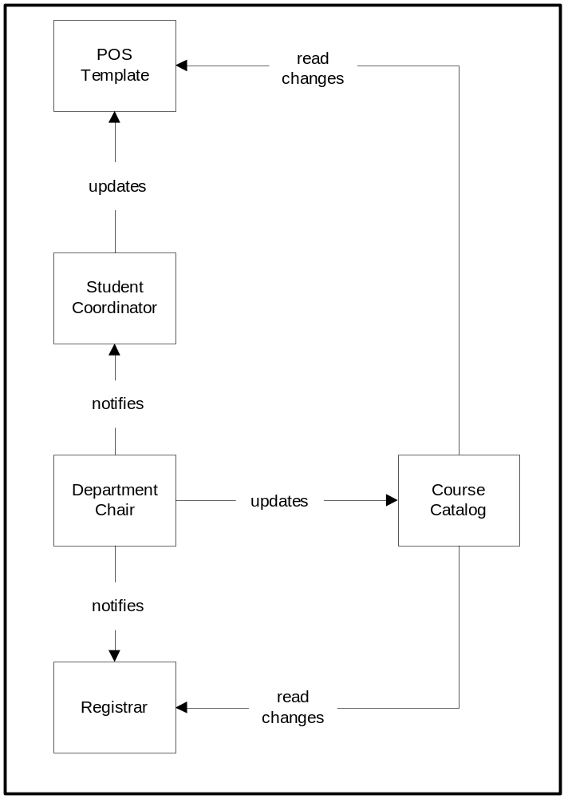

Determine course offerings – (A) Undergrad (from Bond)

- Trigger: Department needs to select courses for next semester.
- Student Coordinator looks through student files to determine courses that are needed.
- Student Coordinator creates list of courses to offer.

Undergrad Course Selection
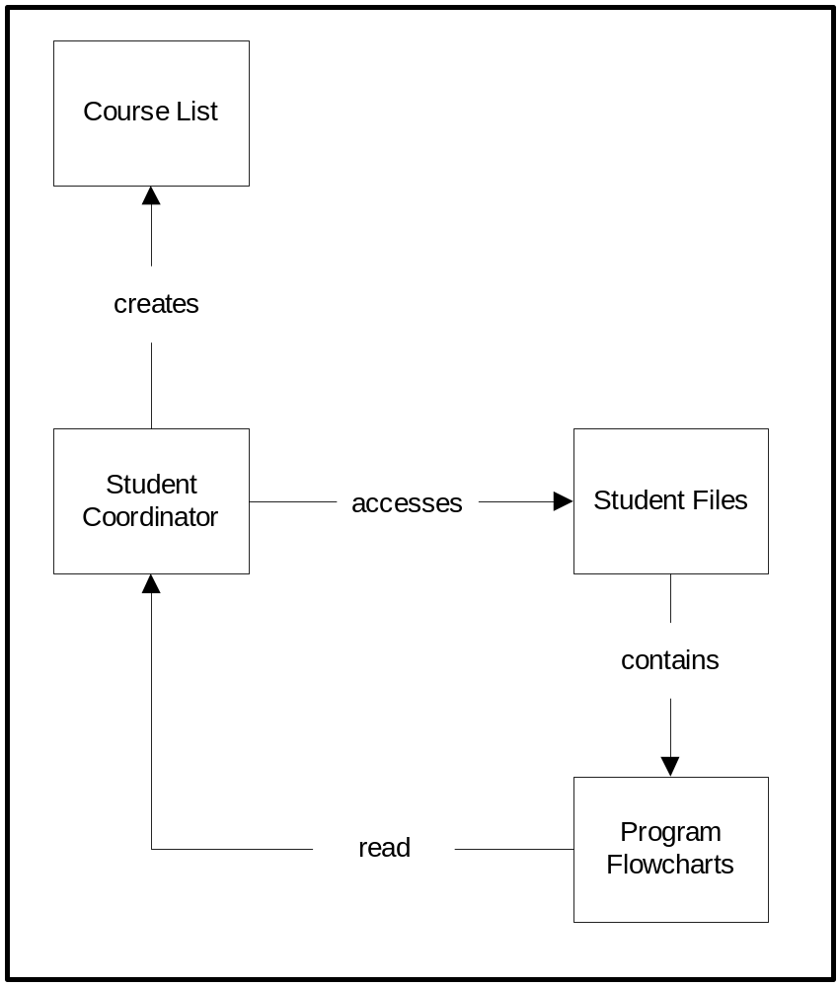

Determine course offerings – (B) Grad (from Bond)

- Trigger: Department needs to select courses for next semester.
- Department Head listens to grad students to determine what courses they need to take.
- Department Head creates list of courses to offer.

Grad Course Selection

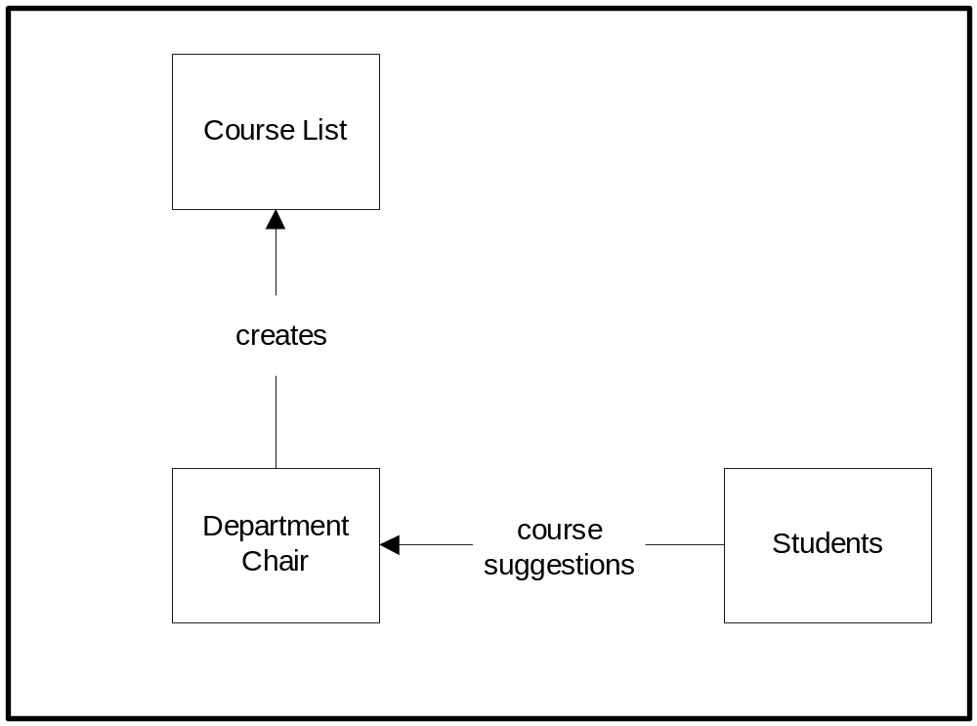
Update POS – (A) Undergrad – new

New freshman undergraduate Student sets up/updates POS. (From Ros)
- Trigger: Student brings blank registration form to meeting with Student Coordinator (Ros).
- Meeting between Ros and Student.
- Ros retrieves placement exam scores for student from Banner. (during meeting)
  - Alternate: Later semesters, she retrieves grades/courses from banner.
- Ros creates/updates program flowchart to indicate courses to take. (during meeting)
- Ros updates Word document (soft copy of flowchart) with student’s info. (during meeting)
- Ros tells student what classes to take (based on flowchart)
- Student updates registration form. (during meeting)
- Ros signs reg form.
- Ros creates paper file folder for student. (during meeting)
- Ros files copy of reg form, flowchart.
- Meeting ends.

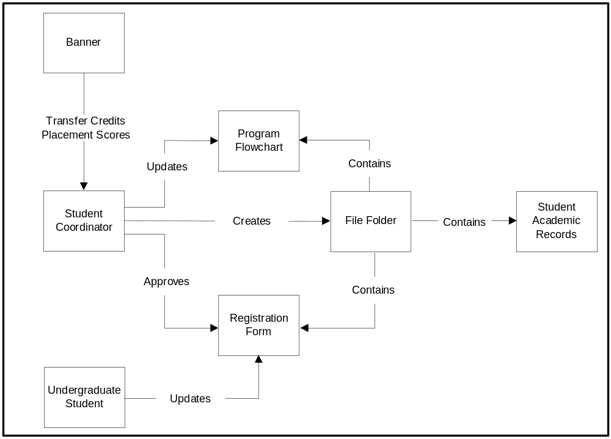Undergraduate Domain Model

Update POS – (B) Undergrad – transfer

Transfer undergraduate Student sets up POS. (From Ros)
- Trigger: Student brings blank registration form to meeting with Student Coordinator (Ros).
- Meeting between Ros and Student.
- Ros retrieves transfer credits for student from Banner. (during meeting)
- Ros creates/updates program flowchart to indicate courses to take. (during meeting)
- Ros updates Word document with student’s info. (during meeting)
- Ros creates paper file for student. (during meeting)
- Student updates registration form. (during meeting)
- Meeting ends.

Undergraduate Domain Model

Update POS – (C) Undergrad – Humanities

New freshman undergraduate Student sets up POS – Humanities department. (From Marilyn Goravitch, Student Coordinator, Humanities)
- Trigger: Student meets with Advisor.
- Advisor retrieves placement exam scores for student from Banner. (during meeting)
- Advisor updates program flowchart to indicate courses to take. (during meeting)
- Student updates registration form. (during meeting)
- Advisor signs registration form.
- Advisor updates file folder (A) with flowchart, copy of reg form.
- Meeting ends.
- Student meets with Student Coordinator.
- Student coordinator updates file folder (SC) with copy of reg form.

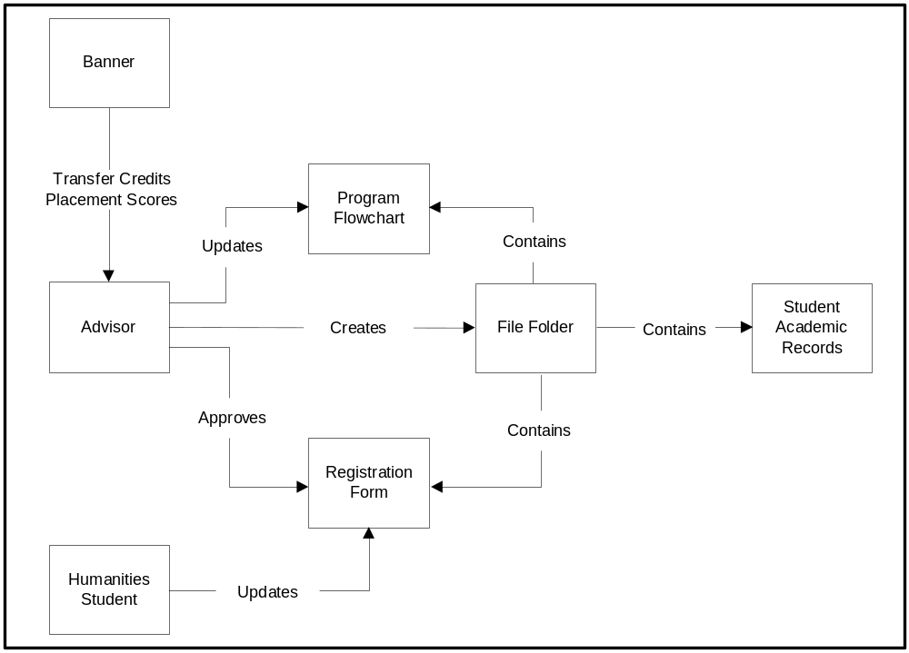Humanities Student Domain Model

Update POS – (D) Grad Program Plan or Reg form

New graduate Student updates program plan and/or registration form. (From Ros)
- Trigger: Student brings blank program plan form to meeting with Advisor.
- Meeting between Advisor and Student.
- Advisor retrieves degree requirements for student’s major from course catalog or flowchart. (during meeting)
- Student updates one or both of:
  - program plan to indicate courses to take. (during meeting)
  - registration form. (during meeting)
- Advisor signs registration form and/or program plan.
- Meeting ends.
- Student meets with Department Head.
- Department Head signs student’s registration form and/or program plan.
- Meeting ends.
- Student meets with Student Coordinator.
- Student Coordinator (Ros) gets copy of student’s registration form and/or program plan (during meeting).
- Ros updates paper file folder for student. (Files copy of form and/or program plan)

Alternate paths:
  - Student gives registration form and/or program plan directly to Ros, who gets department head signature, so steps 8-10 are skipped.
  - Student’s advisor gets form signed and turns in to Ros, so steps 8-11 are skipped.

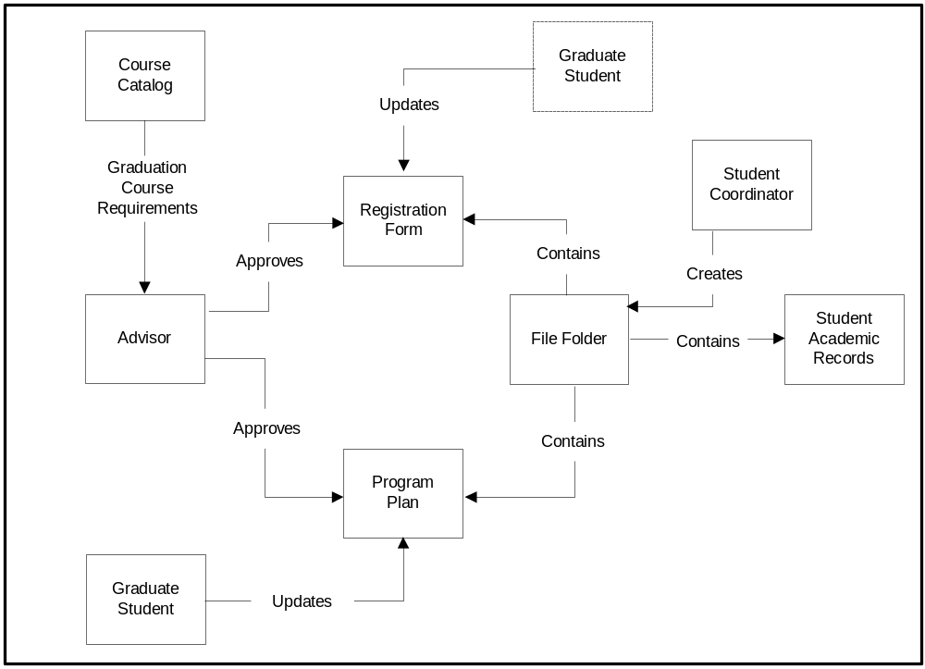
Graduate Student Domain Model

Update POS – (E) Student views POS.

    - Trigger: Student meets with Student Coordinator (Ros).
    - Ros retrieves file for student. (during meeting)
    - Student can review existing program plan, flowchart, etc.

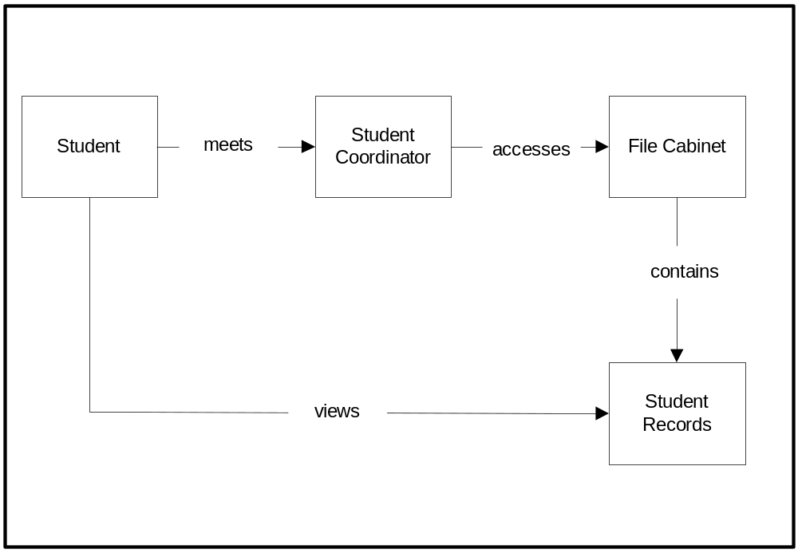 Student Views Files

Student petitions to graduate – (from Ass Registar)

- Trigger: Student fills out PTG form.
- Student gets advisor signature on form.
- Student takes form to registrar.
- Registrar keeps copy of PTG, sends copy to Dept Chair, copy to student.
- Registrar gets transcript from Banner. (print)
- Registrar gets degree requirements from course catalog.
- Registrar gets student file from academic records (course substitution forms, MS program plan, etc)
- Registrar manually verifies that degree requirements have been met.
  - If any questions, go to department chair.
- Registrar generates letter to student.
  - GPA, hours – from Banner
  - Indicates remaining requirements in progress, any current courses
- Mail letter to student
- Update PTG file folder (stapled packet) with letter, PTG form, transcript, copy of substitution forms from student file.

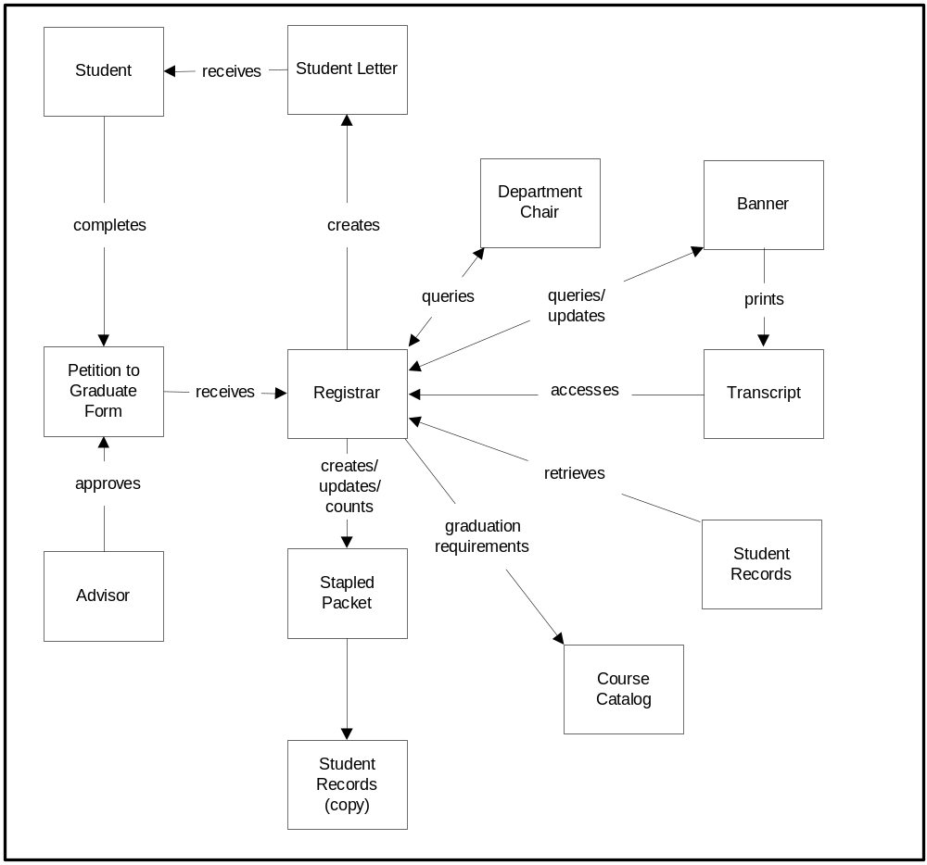Petition to Graduate Domain Model

Query system for students who have petitioned to graduate – (from Ass Registrar)

- Trigger: Registrar wants to check # graduates.
- Registrar goes through stapled PTG packets and counts them.

Clear Petition to Graduate Records after graduation

- Trigger: Timer 1 week after semester.
- Registrar goes through stapled PTG packets
  - If student graduated, PTG packet is filed in academic records. (Keep for 5 years)
  - If didn’t graduate, PTG packet is kept until next semester. (Student has to repetition to graduate to move file from the “old” pile to the “current” pile)

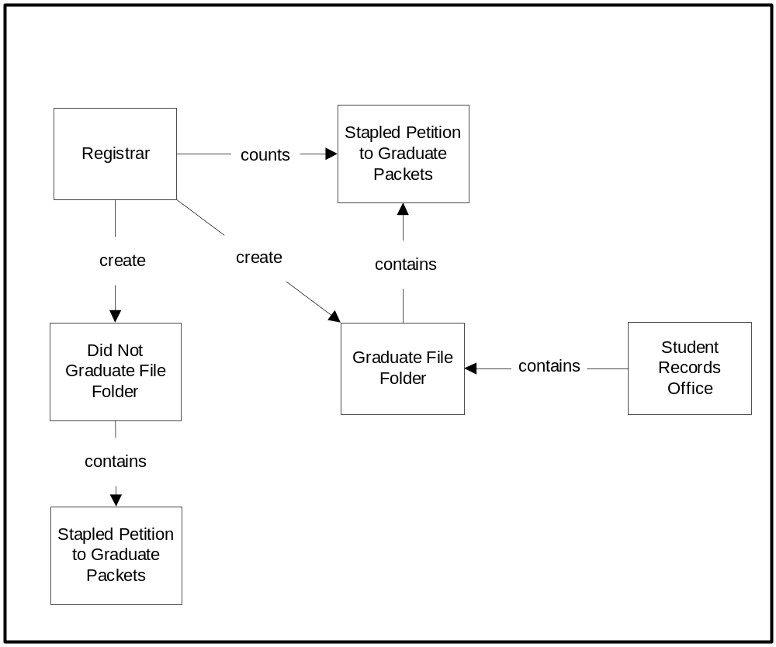Stapled Petition to Graduate Packet Management

Update student files – (A) By Department (from Ros)

- Trigger: End of the semester.
- Student Coordinator goes through each student file
  - Get course name/number and grade from Banner.
  - Update student file with course number and grade.

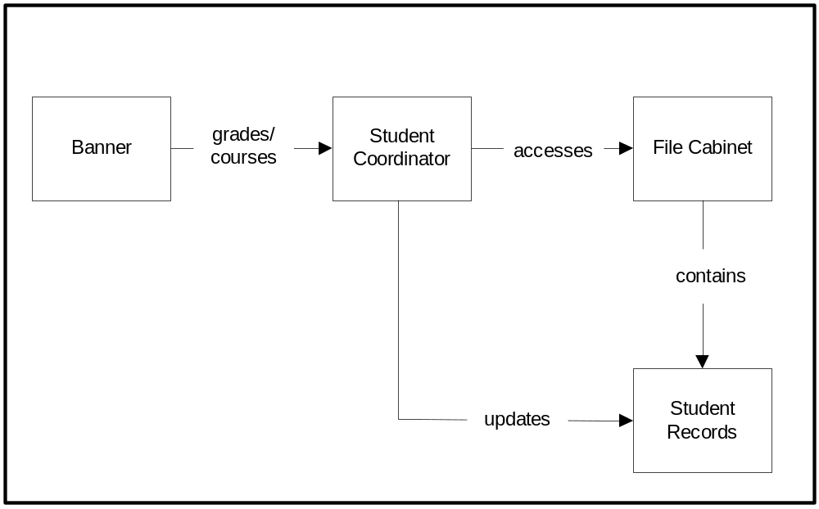 Update Student Files

Update student files – (B) Update Banner with course grades – (from Ass Registrar)

- Trigger: End of the semester. Professor enters grades on piece of paper.
- Student Coordinator (or Dept Chair) copies grades and files copy.
- Student Coordinator sends paper grades to Registrar.
- Registrar enters grades for course into Banner.
- Registrar files paper copy of course grades.

* This is outside of our system, so there is no corresponding “SHOULD BE”.

Protect Student Records – (from Bond)

- Trigger: Always.
- Student Coordinator locks file cabinet and/or office with records.
- Computer records are secured via FIT system security (login/password).
- Sensitive paper files are shredded.

Protect Student Records
